DAYANANDA SAGAR UNIVERSITY

SCHOOL OF ENGINEERING

DEPARTMENT OF

COMPUTER SCIENCE AND ENGINEERING

(Artificial Intelligence & Machine Learning)

Database Management Systems Laboratory Manual

22AM2403

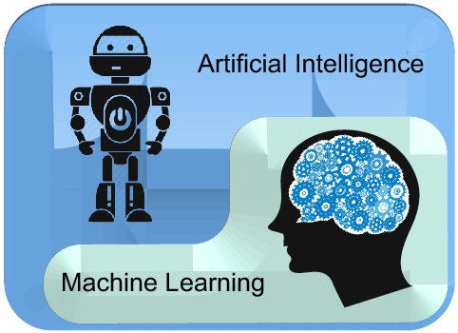

Dayananda Sagar University

Innovation City Campus, Hosur Main Road, Kudlu Gate, Bangalore, India, Karnataka -560068

DAYANANDA SAGAR UNIVERSITY

SCHOOL OF ENGINEERING

Devarakaggalahalli, harohalli, Kanakapura Road,Ramanagara Dt, Bengaluru, Karnataka 562112

**School of Engineering**

**Vision and Mission**

**Vision**

To be a centre of excellence in education, research & training, innovation & entrepreneurship and to produce citizens with exceptional leadership qualities to serve national and global needs.

**Mission**

To achieve our objectives in an environment that enhances creativity, innovation and scholarly pursuits while adhering to our vision.

**Values**

***The Pursuit of Excellence***

A commitment to strive continuously to improve ourselves and our systems with the aim of becoming the best in our field.

***Fairness***

A commitment to objectivity and impartiality, to earn the trust and respect of society.

***Leadership***

A commitment to lead responsively and creatively in educational and research processes.

***Integrity and Transparency***

A commitment to be ethical, sincere and transparent in all activities and to treat all individuals with dignity and respect.

DAYANANDA SAGAR UNIVERSITY

SCHOOL OF ENGINEERING

Devarakaggalahalli, harohalli, Kanakapura Road,Ramanagara Dt, Bengaluru, Karnataka 562112

**Computer Science and Engineering**

**(Artificial Intelligence and Machine Learning)**

**Vision**

* Develop highly competent engineers in the field of AI & ML contributing globally to the benefit of industry and society.

**Mission**

* To develop state-of-the-art academic and infrastructural facilities with the latest tools and other learning resources supported by curriculum that can produce self-sustainable professionals.
* To emerge as a research centre that interacts with industry on a regular basis for imparting wholistic curriculum to the students.
* To impart emerging skill sets that the industry require, apart from ensuring that the soft skills of the learners are given adequate thrust.

DAYANANDA SAGAR UNIVERSITY

SCHOOL OF ENGINEERING

Hosur Rd, Kudlu Gate, Srinivasa Nagar, Hal Layout, Singasandra, Bengaluru, Karnataka 560068

**Computer Science and Engineering**

**(Artificial Intelligence and Machine Learning)**

**Program Educational Objectives (PEO's)**

* **PEO1.** Apply appropriate theory, practices, and tools of machine intelligence to the specification, design, implementation, maintenance, and evaluation in the workplace or in higher education.
* **PEO2.** Adapt, contribute and innovative new technologies in their computing professional by working in teams to design, implement, and maintain in the key domains of Artificial Intelligence and Machine Learning.
* **PEO3.** Function effectively in the work place as competent Artificial Intelligence and Machine Learning Professionals, Entrepreneurs or Researchers or maintain employment through lifelong learning such as professional conferences, certificate programs or other professional educational activities, ethics, and societal awareness.

**Programme Outcome (PO's)**

* **PO1. Engineering knowledge:** Apply the knowledge of mathematics, science, engineering fundamentals, and an engineering specialization to the solution of complex engineering problems.
* **PO2. Problem analysis:** Identify, formulate, review research literature, and analyze complex engineering problems reaching substantiated conclusions using first principles of mathematics, natural sciences, and engineering sciences.
* **PO3. Design/development of solutions:** Design solutions for complex engineering problems and design system components or processes that meet the specified needs with appropriate consideration for the public health and safety, and the cultural, societal, and environmental considerations.
* **PO4. Conduct investigations of complex problems:** Use research-based knowledge and research methods including design of experiments, analysis and interpretation of data, and synthesis of the information to provide valid conclusions.
* **PO5. Modern tool usage:** Create, select, and apply appropriate techniques, resources, and modern engineering and IT tools including prediction and modeling to complex engineering activities with an understanding of the limitations.
* **PO6. The engineer and society:** Apply reasoning informed by the contextual knowledge to assess societal, health, safety, legal and cultural issues and the consequent responsibilities relevant to the professional engineering practice.
* **PO7. Environment and sustainability:** Understand the impact of the professional engineering solutions in societal and environmental contexts, and demonstrate the knowledge of, and need for sustainable development.
* **PO8. Ethics:** Apply ethical principles and commit to professional ethics and responsibilities and norms of the engineering practice.
* **PO9. Individual and team work:** Function effectively as an individual, and as a member or leader in diverse teams, and in multidisciplinary settings.
* **PO10. Communication:** Communicate effectively on complex engineering activities with the engineering community and with society at large, such as, being able to comprehend and write effective reports and design documentation, make effective presentations, and give and receive clear instructions.
* **PO11. Project management and finance:** Demonstrate knowledge and understanding of the engineering and management principles and apply these to one’s own work, as a member and leader in a team, to manage projects and in multidisciplinary environments.
* **PO12. Life-long learning:** Recognize the need for, and have the preparation and ability to engage in independent and life-long learning in the broadest context of technological change.

**Program Specific Outcomes (PSO's)**

* **PSO1.** **Cognitive Outcome:** Solve complex engineering problems in computing by applying the principles in Artificial Intelligence, Machine Learning, Network Engineering, Software Engineering, Data Engineering and Intelligent Systems.
* **PSO2.** Skill & Design Outcome: Apply technical skills and research skills through professional societies, certification programs, projects, internships and laboratory exercises to design & develop algorithms, Programs, and Projects using modern software tools to provide the sustainable solutions to Computer Science, Artificial Intelligence and Machine Learning problems related to the society and environment.



|  |  |  |  |
| --- | --- | --- | --- |
| **Perquisite Courses (if any)** | | | |
| **#** | **Sem / Year** | **Course Code** | **Title of the Course** |
| **1** | **III/II** | **20CS2305** | **COMPUTATIONAL THINKING WITH PYTHON** |
| **2** | **IV/II** | **20AM2401** | **Artificial Intelligence -I** |

**COURSE OBJECTIVES:**

1. Acquire the concept of databases, Entity-Relationship Model and relational model for

creating and designing databases for the real-world scenario.

1. Develop queries to extract data from the databases using a structured query language.
2. Differentiate SQL and NoSQL.
3. Demonstrate the operations on MongoDB, Database connectivity with front end and
4. Optimize the Database design using Normalization Concepts.
5. Understand the importance of Transaction Management, Concurrency control mechanism and recovery techniques.

**COURSE OUTCOMES:**

|  |  |  |
| --- | --- | --- |
| **CO No.** | **Outcomes** | **Bloom’s Taxonomy Level** |
| 1 | Use the basic concepts of database management system in the design and creating database blueprint using E-R model and relational model. | L3 |
| 2 | Formulate SQL and NOSQL queries for building structure and unstructured databases | L3 |
| 3 | Demonstrate database connectivity using vendor specific drivers | L3 |
| 4 | Apply normalization techniques to design relational database management system | L3 |
| 5 | Adapt Transactional Management, Concurrency control and recovery management techniques in database management system. | L3 |

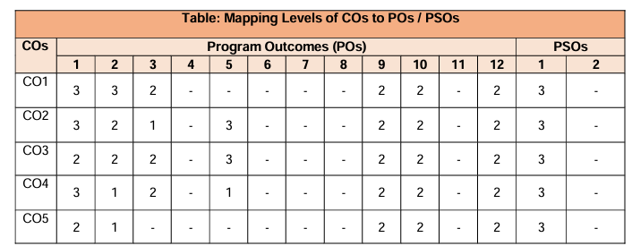



**Instructions for Laboratory Exercises:**

1. Launch MySQL Workbench to open the home screen. Existing connections are shown when you click the MySQL Connections view from the sidebar. No connections exist for first-time users.
2. To add a connection, click the [+] icon to the right of the MySQL Connections title on the [home](https://dev.mysql.com/doc/workbench/en/wb-home.html) screen. This opens the Setup New Connection. Define the Connection Name value,
3. Read the Configure Local Management introduction (shown in the next figure), and press Next to begin defining the new connection parameters.
4. The connection will now be tested. You should see that the connection was successful. If not, click Back and check that you have entered the information correctly.

List of Experiments

|  |  |  |  |  |
| --- | --- | --- | --- | --- |
| Exp No | Experiment Name | Date | Marks | Sign |
| 1 | Design any database with at least 3 entities and establish proper relationships between them. Draw suitable ER/EER diagrams for the system. Apply DCL and DDL commands. |  |  |  |
| 2 | Design and implement a database and apply at least 10 Different DML Queries for the following task. a. For a given input string display only those records which match the given pattern or a phrase in the search string. Make use of wild characters and like operators for the same. Make use of Boolean and arithmetic operators wherever necessary |  |  |  |
| 3 | Write SQL statements to join table and retrieve the combined information from tables. |  |  |  |
| 4 | Execute the Aggregate functions count, sum, avg, min, max on a suitable database. Make use of built in functions according to the need of the database chosen. |  |  |  |
| 5 | Retrieve the data from the database based on time and date functions like *now(), date(), day(), time()* etc., Use of group by and having clauses. |  |  |  |
| 6 | Write and execute database trigger. Consider row level and statement level triggers. |  |  |  |
| 7 | Write and execute program to perform operations on MongoDB Database. |  |  |  |
| 8 | Write and execute program to perform CRUD operations. |  |  |  |
| **Open Ended Experiments** | | | | |
| 9 | Consider the Table “employees”, write a SQL query to remove all the duplicate emails of employees keeping the unique email with the lowest employee id, return employee id and unique emails. |  |  |  |
| 10 | A salesperson is a person whose job is to sell products or services. Consider the table “Sales” [given below]. Write a SQL query to find the top 10 salesperson that have made highest sale. Return their names and total sale amount. |  |  |  |

|  |  |  |
| --- | --- | --- |
| **Internals (40M)** | **Lab Record & Attendance (20M)** | **Total Marks (60M)** |
|  |  |  |

# **World database tables and attributes:**

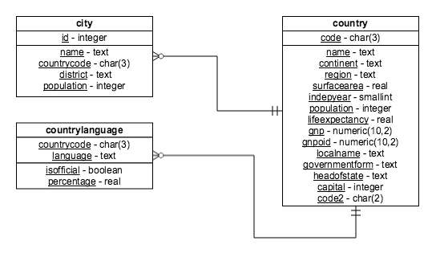

# EXPERIMENT: 1

# AIM: To Design any database with at least 3 entities and establish proper relationships between them. Draw suitable ER/EER diagrams for the system. Apply DCL, DDL, and DML commands.

PROGRAM:

**Consider the schema of WORLD database.**

**-- ER diagram of World database**

**-- DCL commands**

**========================== DCL ================**

**-- Grant and Revoke**

**-- select user from mysql.user;**

**select user from mysql.user;**

**-- show grants for 'user@localhost';**

**show grants for 'mysql.session'@'localhost';**

**-- grant all previleages on *.* to `mysql.infoschema`@`localhost`;**

**grant ALL PRIVILEGES on *.* to 'root'@'localhost';**

**-- revoke all previleages on *.* from `mysql.infoschema`@`localhost`--**

**revoke;**

**revoke ALL PRIVILEGES on *.* from 'root'@'localhost';**

**-- DDL commands**

**-- Create drop alter rename create index drop index modify**

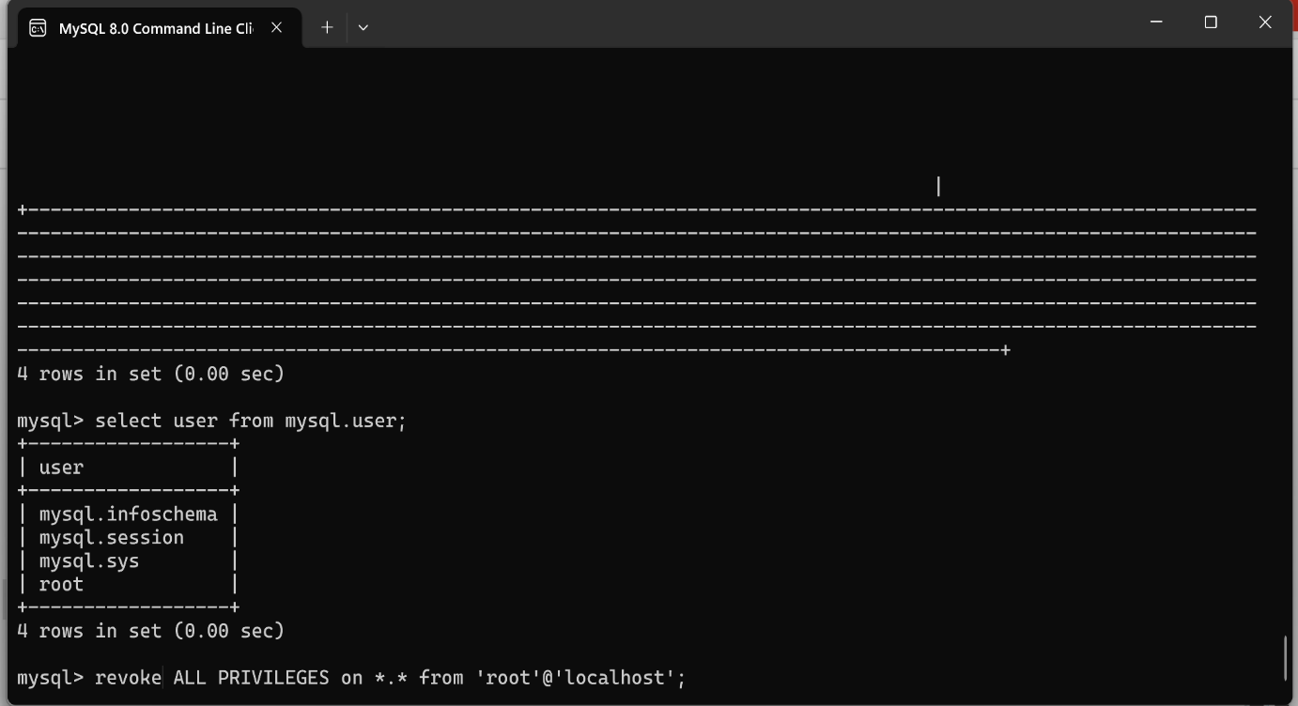

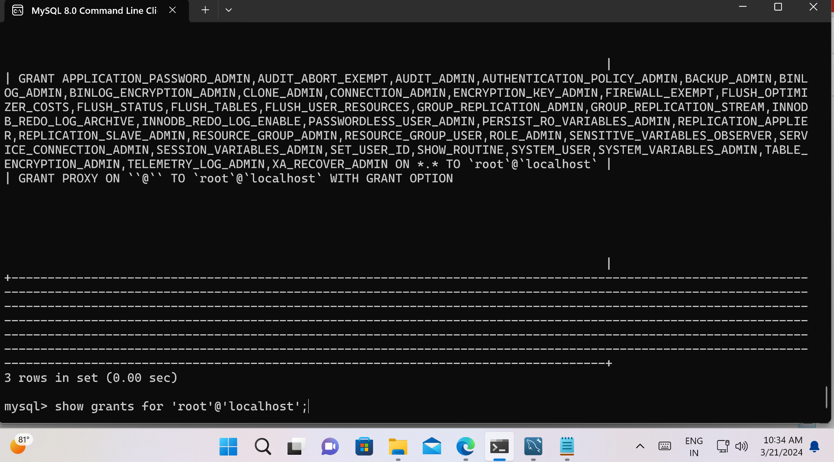

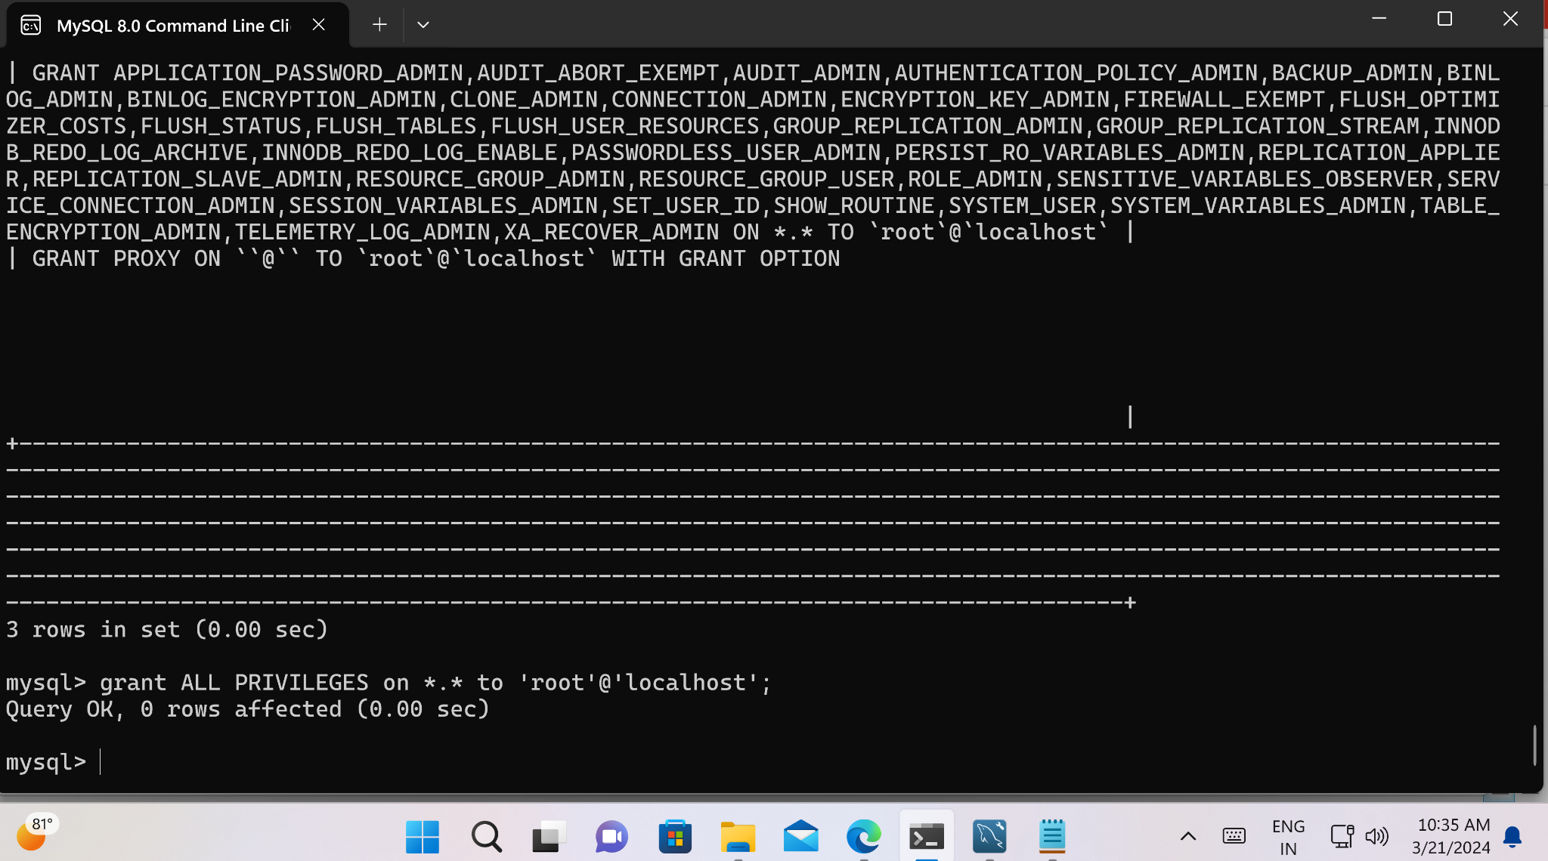

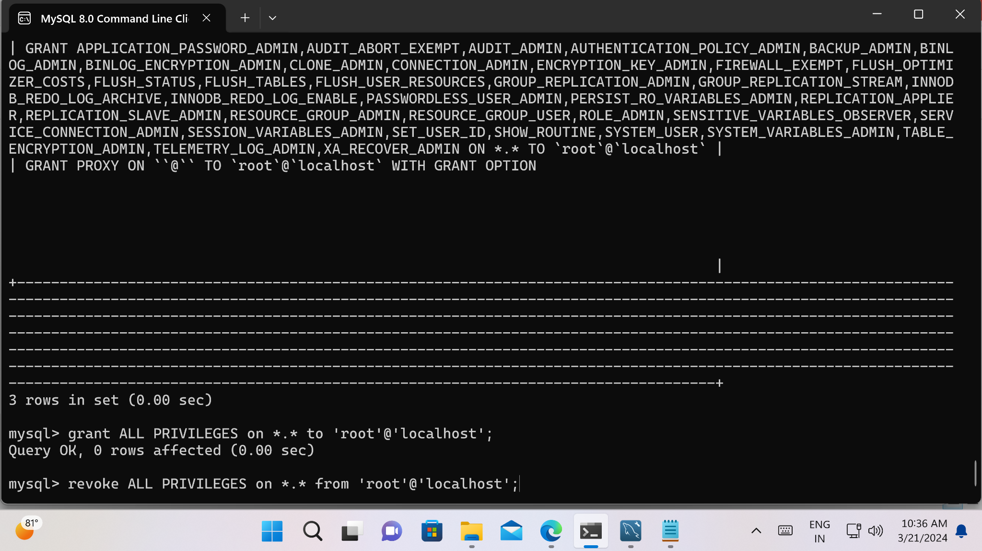

**========================== DCL ================**

**create user 'san5'@'localhsot' identified by 'san';**

**show grants for 'san5'@'localhsot';**

**grant select on databasename.tablename to 'san5'@'localhsot';**

**grant select on *.* to 'san5'@'localhsot';**

**grant insert on march2.cst to 'san5'@'localhsot';**

**insert into march2.cst values (111,"cstname","3rd","a",500);**

**insert into march2.cst values (333,"cstname","3rd","a",500);**

**delete from march2.cst;**

**update march2.cst set deptgrade = "A+" where deptid = 111;**

**update march2.cst set deptid = 1111 where deptgrade = "A+";**

**grant update(deptid) on march2.cst to 'san5'@'localhsot';**

**revoke update(deptid) on march2.cst from 'san5'@'localhsot';**

**-- . is all databases and all the tables**

**-- change user**

**-- system mysql -u san -p; change user from root to san**

**-- system mysql -u root -p; to chage user from san2 to root**

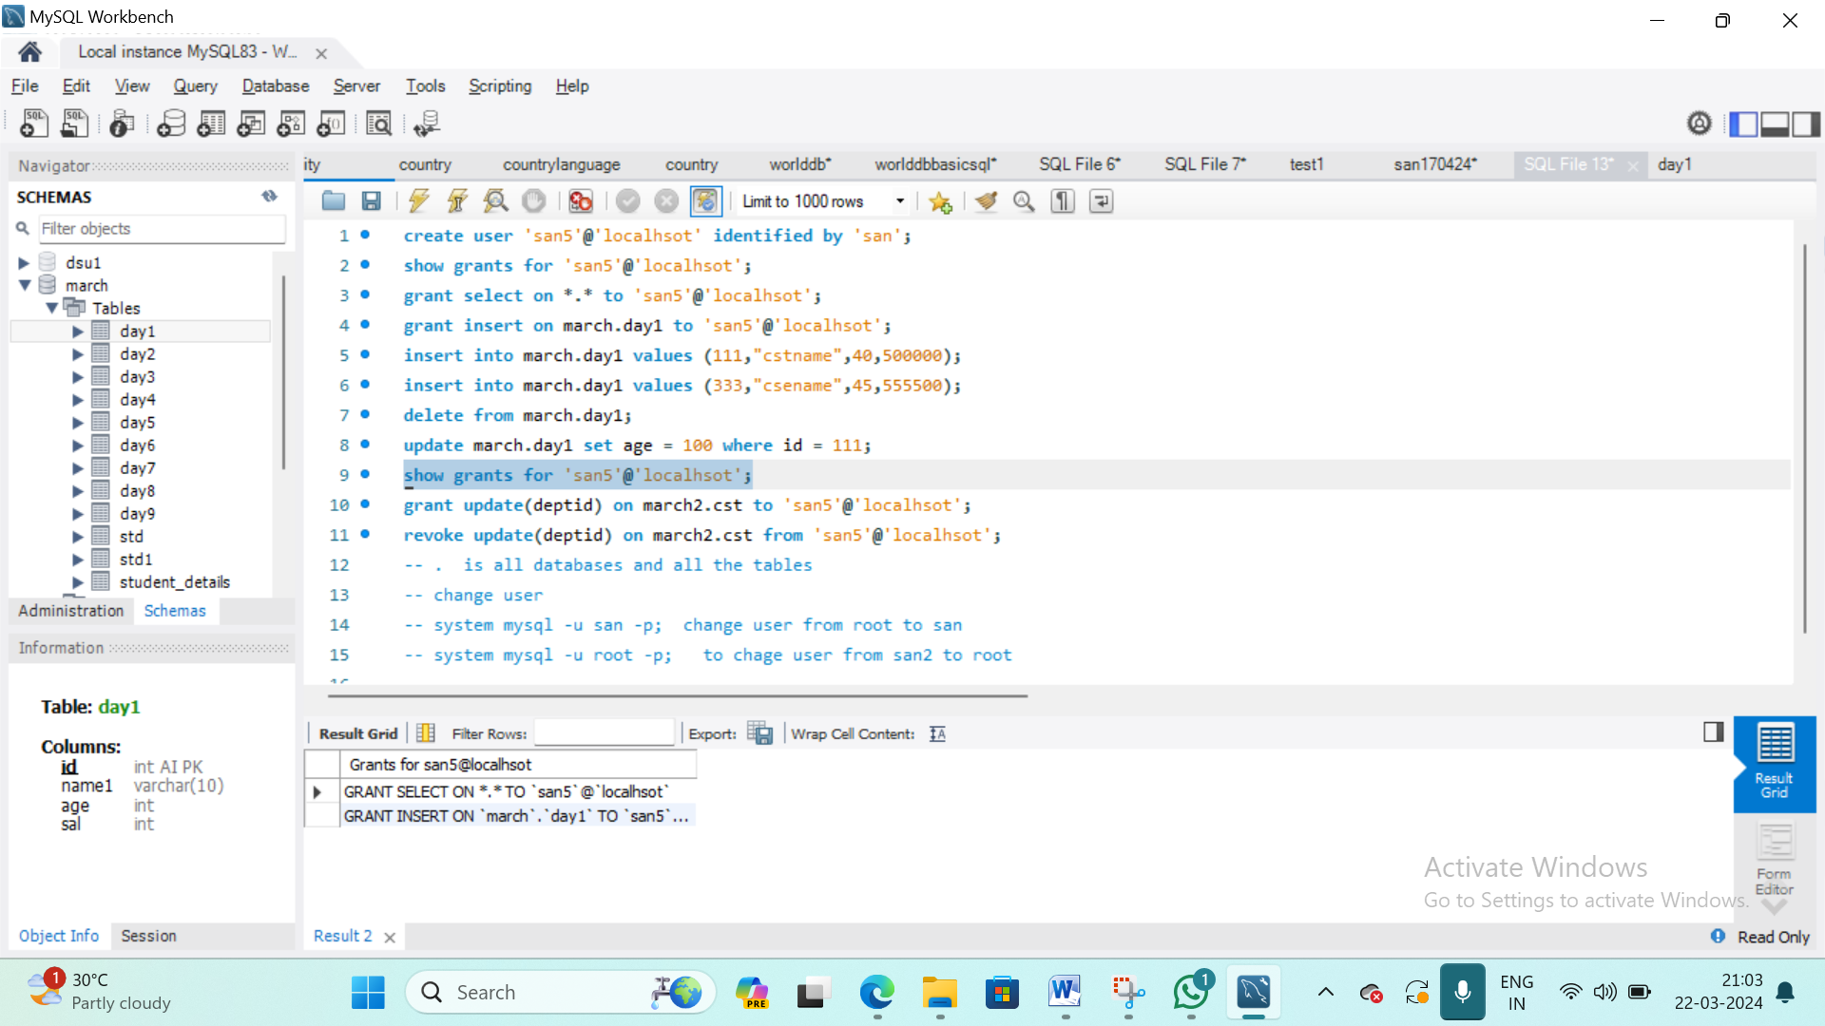

**===================== DDL =======================**

**use cst;**

**create table std (**

**id int,**

**name1 varchar(100)**

**);**

**desc std;**

**alter table std**

**add placement varchar(100);**

**alter table std**

**modify column placement int;**

**desc std;**

**alter table std**

**drop placement;**

**desc std;**

**alter table std**

**rename column name1 to name;**

**============================== DML ==============================**

1. Create a SQL statement to display columns Id, Name, Population from the city table and limit results to first 10 rows only.

Select Id,name,Population from city limit 10;

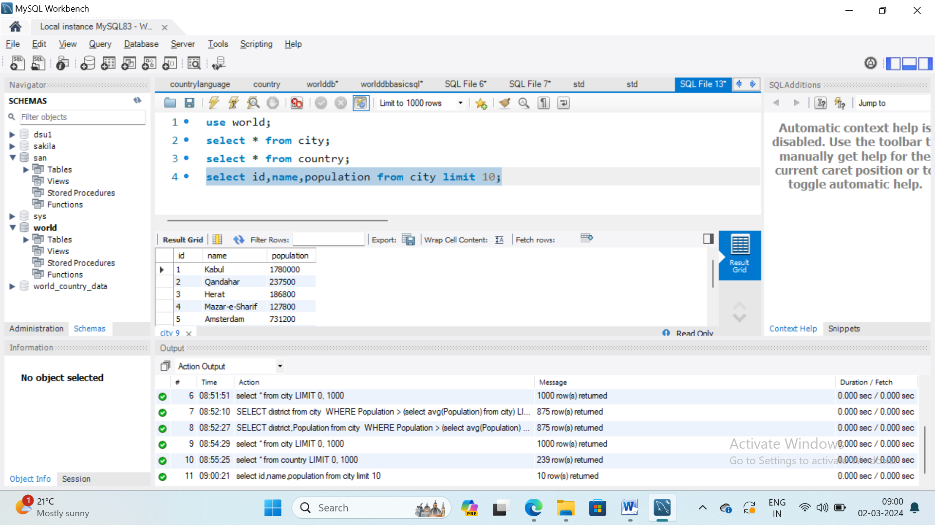

1. Create a SQL statement to display columns Id, Name, Population from the city table and limit results to rows 31-40

Select Id,Name, Population from city limit 30,10;

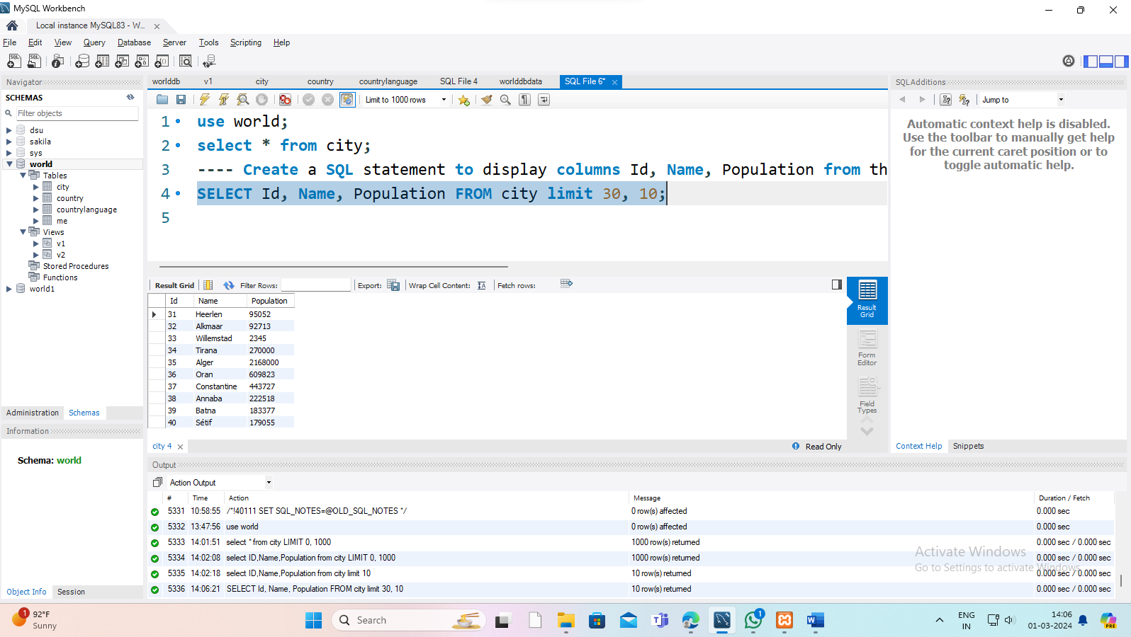

1. Create a SQL statement to find only those cities from city table whose population is larger than 2000000.

Select Name, population from city where population >2000000

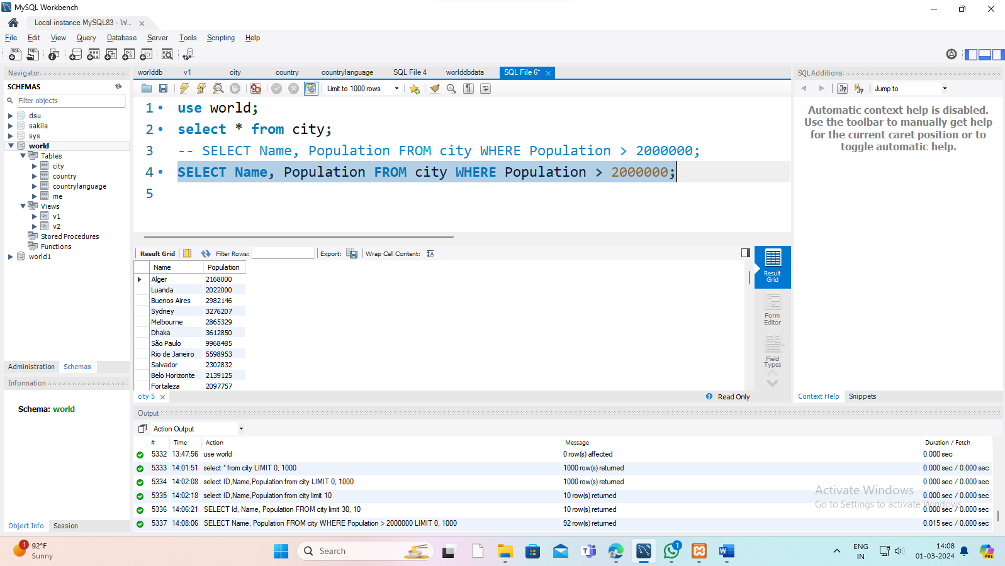

1. Select the Districts with population above the average population of all the districts in the table.

Select district from city where population > (select avg(population) from city);

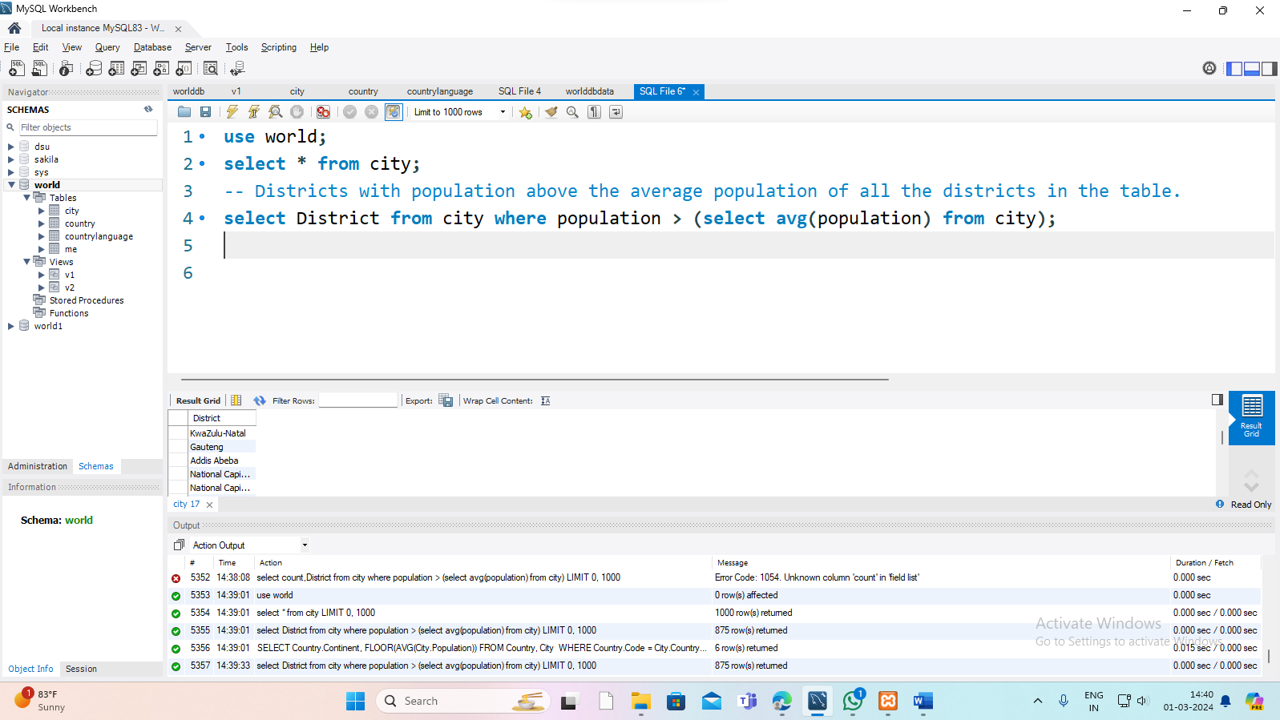

1. What is the country code for Kabul

SELECT * from city WHERE Name = ‘Kabul’

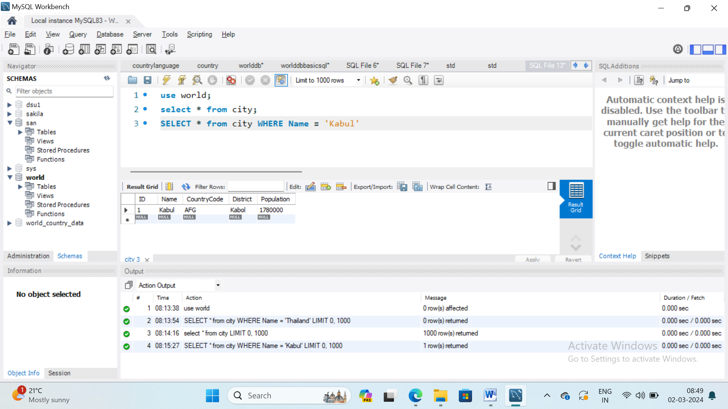

1. Find out what the population and average life expectancy for people in Argentina.

(ARG) is **(37032000, 75.10000)**

SELECT population, AVG(lifeExpectancy) FROM country WHERE CODE='arg';

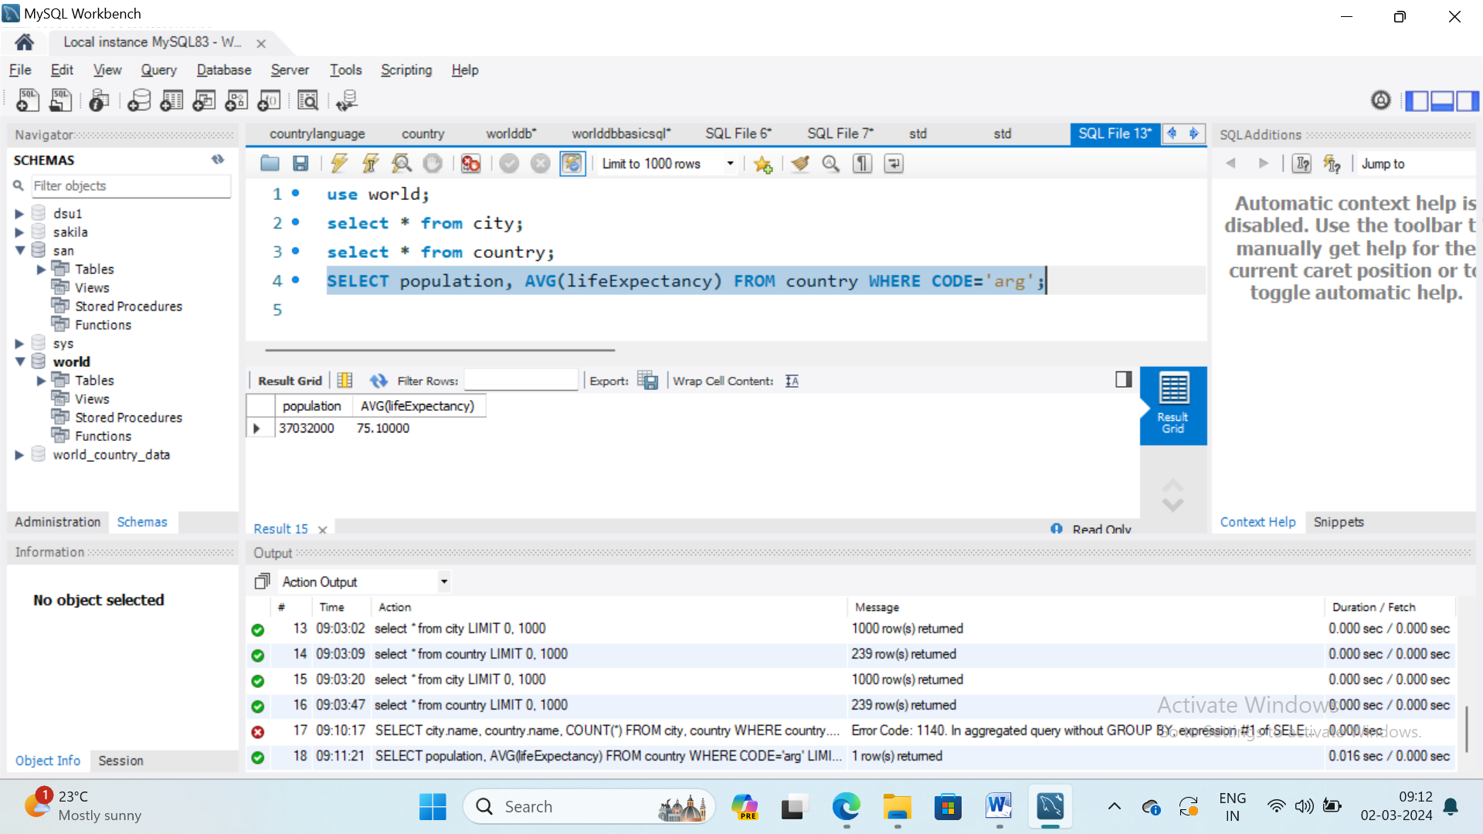

1. Using IS NOTNULL,ORDER BY,LIMIT,what country has the highest life expectancy?

**(Andorra, 83.5)**

SELECT * FROM country;

SELECT NAME,lifeExpectancy FROM country ORDER BY lifeExpectancy DESC LIMIT 1 ;

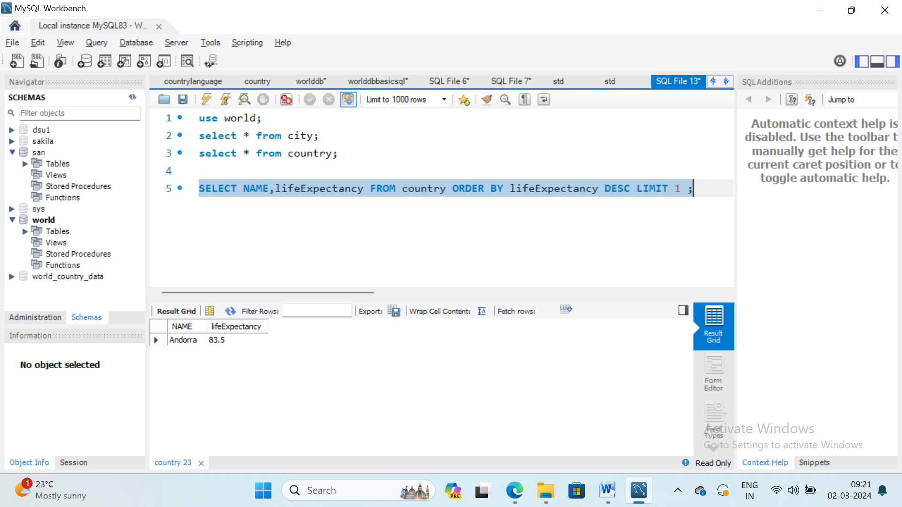

Extra code for practice ========

1.SELECT TOP 3 * FROM Country  
WHERE Continent='Africa';

2.SELECT * FROM countrylanguages  
WHERE Language IN ('Dutch', 'English', 'Ambo');

3. SELECT MIN(Percentage) FROM Countrylanguages;

4. SELECT * FROM City WHERE Population BETWEEN 100000 AND 200000.

5. INSERT INTO *table_name* (*column1*,*column2*,*column3*, ...)  
VALUES (*value1*,*value2*,*value3*, ...);

VIVA QUESTIONS

# EXPERIMENT: 2

AIM: To write a SQL Query for Use of order by functions and LIKE function.

PROGRAM:

Select 25 cities around the world that start with the letter 'F' in a single SQL query.

SELECT NAME FROM city WHERE NAME LIKE 'f%' ORDER BY NAME ASC LIMIT 25;

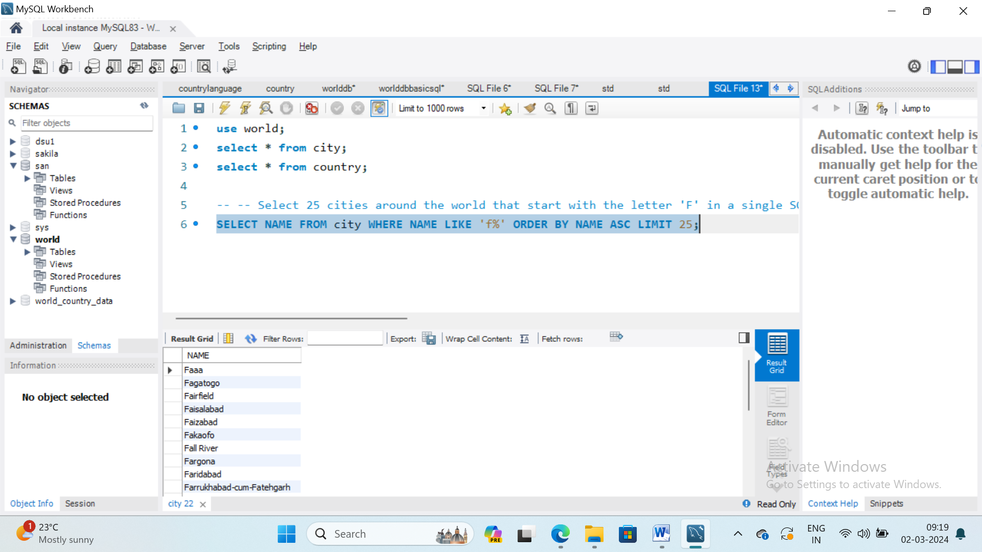

1. Show the countries which have a name that includes the word 'United'

SELECT name FROM world

WHERE name LIKE '%United%'

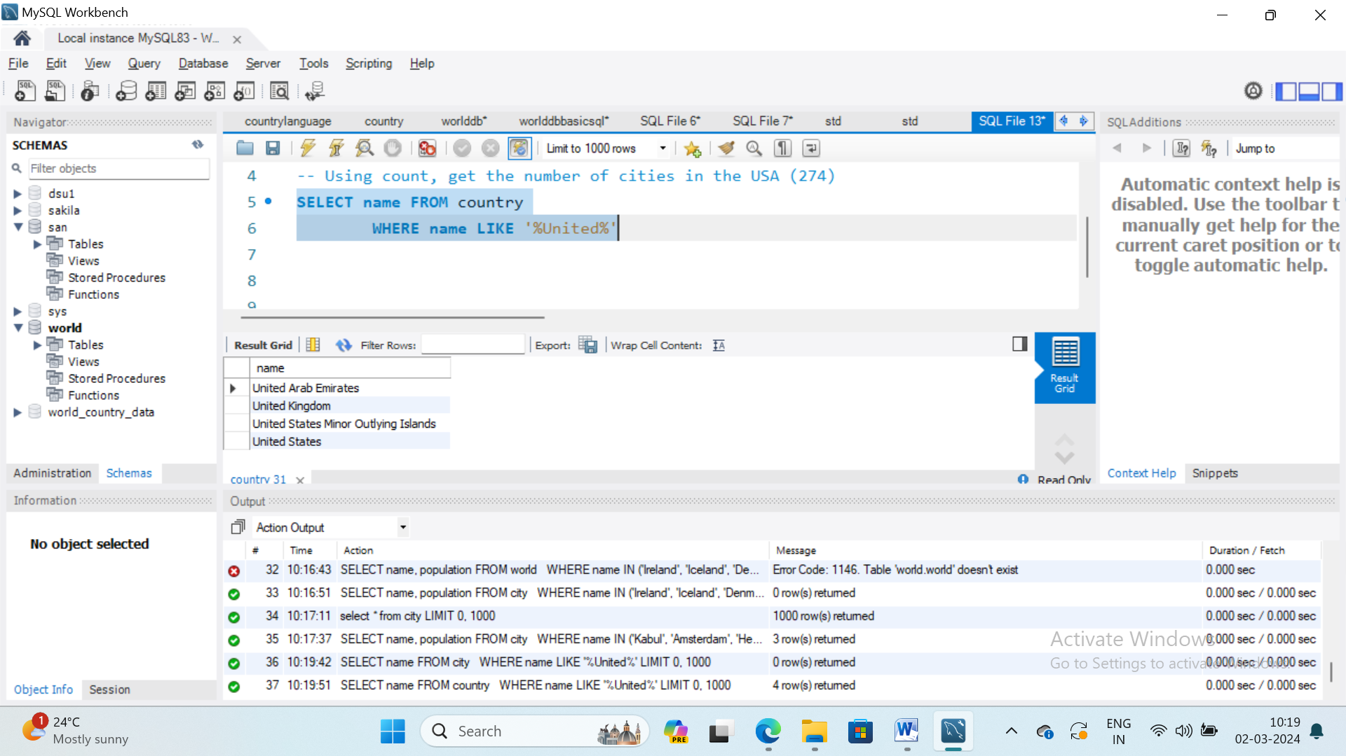

1. Some countries have populations more than three times that of any of their neighbours (in the same continent). Give the countries and continents.

SELECT name, continent FROM country x WHERE

population > ALL

(SELECT population*3 FROM country y

WHERE y.continent = x.continent

AND y.name != x.name)

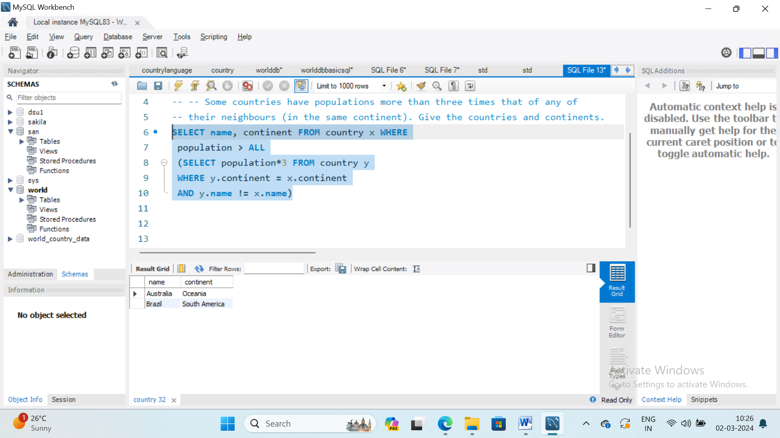

1. Give name and surfacearea from country where surface area between 200000 and 250000.

SELECT name, SurfaceArea

FROM country WHERE SurfaceArea BETWEEN 200000 AND 250000

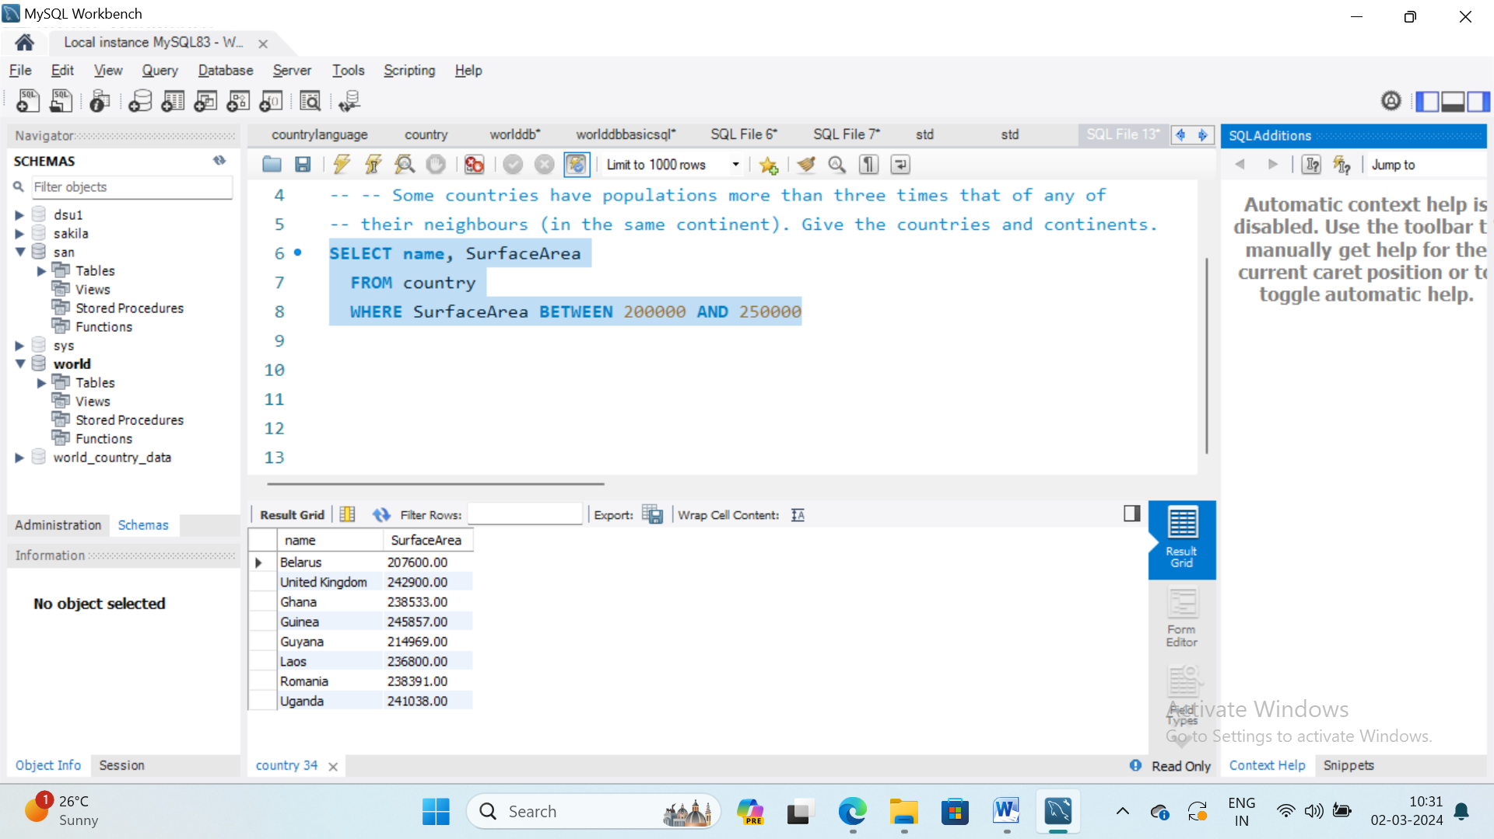

1. Show the name - but substitute Australasia for Oceania - for countries beginning with N.

SELECT name, CASE WHEN continent='Oceania' THEN 'Australasia'

ELSE continent END

FROM country

WHERE name LIKE 'N%'

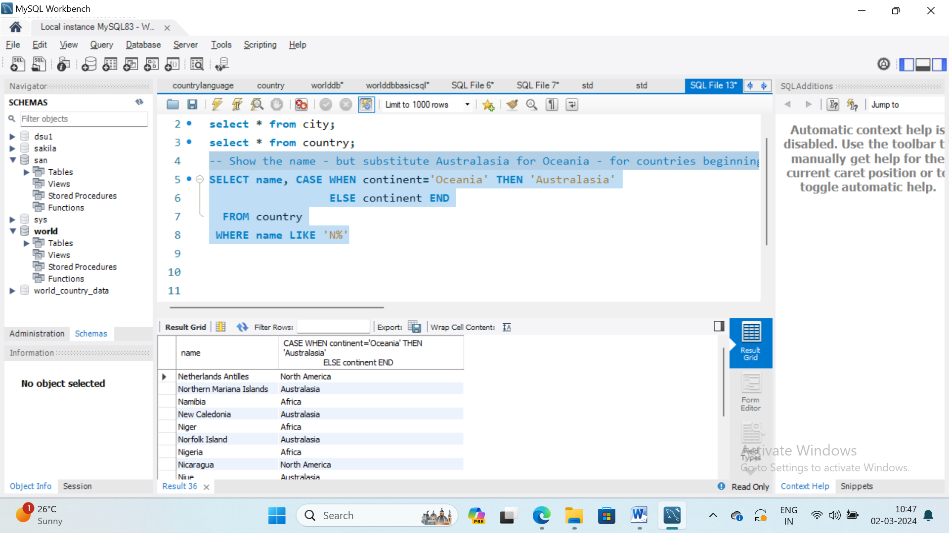

1. Find the largest country (by area) in each continent, show the continent, the name and the area:

SELECT continent, name, surfacearea

FROM country x

WHERE surfacearea >= ALL

(SELECT surfacearea FROM country y

WHERE y.continent=x.continent

AND surfacearea > 0 );

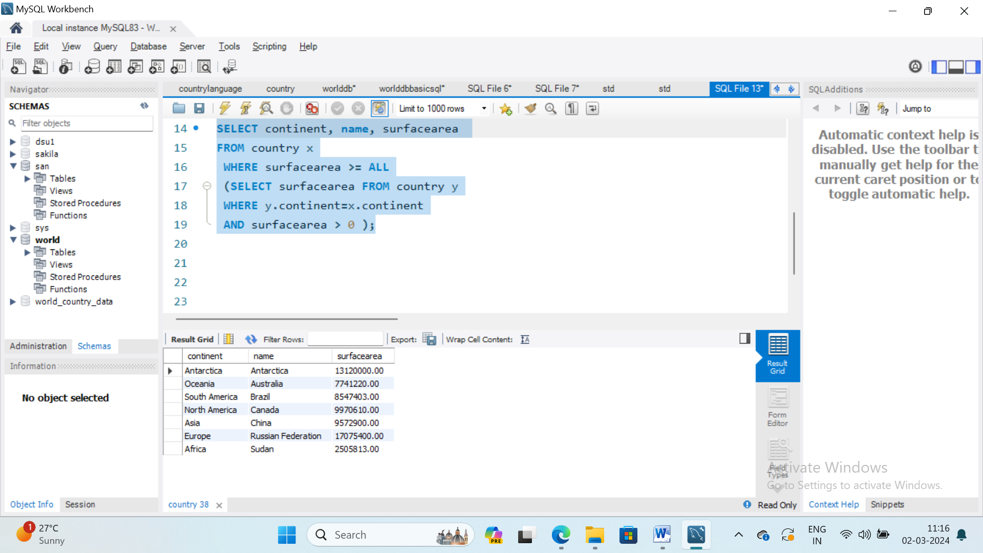

1. List each continent and the name of the country that comes first alphabetically

SELECT continent,name FROM country x

WHERE x.name <= ALL (

SELECT name FROM country y

WHERE x.continent=y.continent);

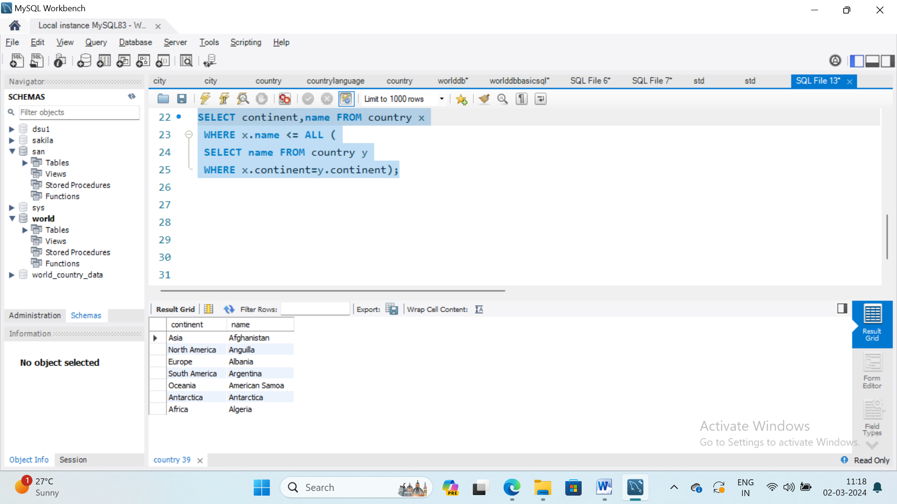

1. Find the continents where all countries have a population <= 25000000. Then find the names of the countries associated with these continents. Show name, continent and population.

SELECT name,continent,population FROM country x

WHERE 25000000 >= ALL (

SELECT population FROM country y

WHERE x.continent=y.continent

AND y.population>0);

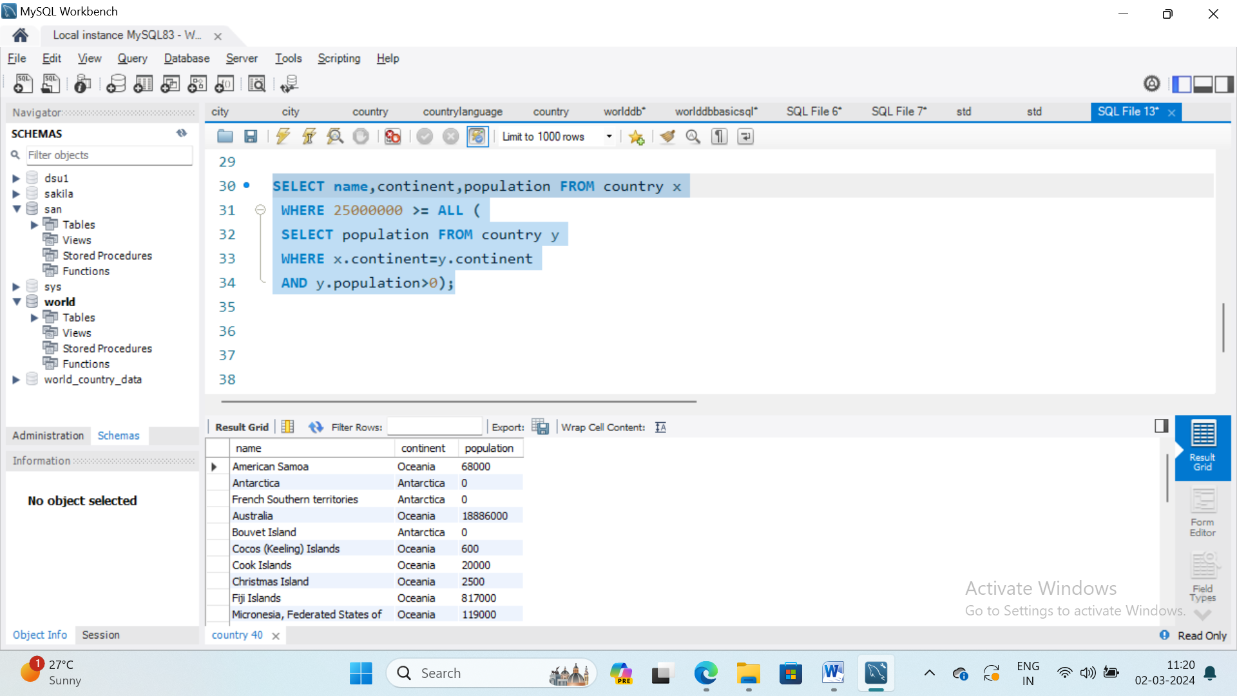

1. Some countries have populations more than three times that of any of their neighbours (in the same continent). Give the countries and continents.

SELECT name, continent FROM country x WHERE

population > ALL

(SELECT population*3 FROM country y

WHERE y.continent = x.continent

AND y.name != x.name);

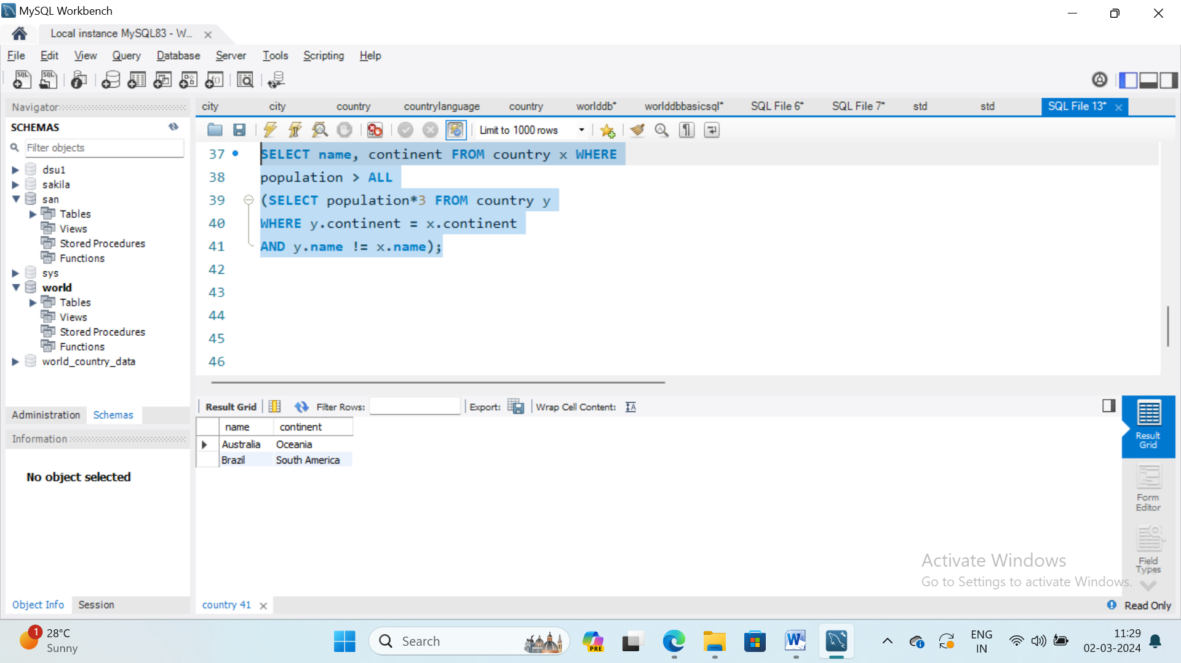

OUTPUT DATA:

VIVA QUESTIONS:

# EXPERIMENT: 3

AIM: Write Sql code to join tables and retrieve the combined information from tables.

PROGRAM:

1. Using LEFT JOIN, ON, what is the capital of Spain (ESP)? (Madrid)

SELECT city.name

FROM city, country

WHERE country.code=city.countryCode

AND country.capital=city.ID

AND country.code='ITA';

SELECT city.name, country.name

FROM country

LEFT JOIN city

ON country.capital=city.ID

AND country.code=city.countryCode

WHERE country.code='ESP';

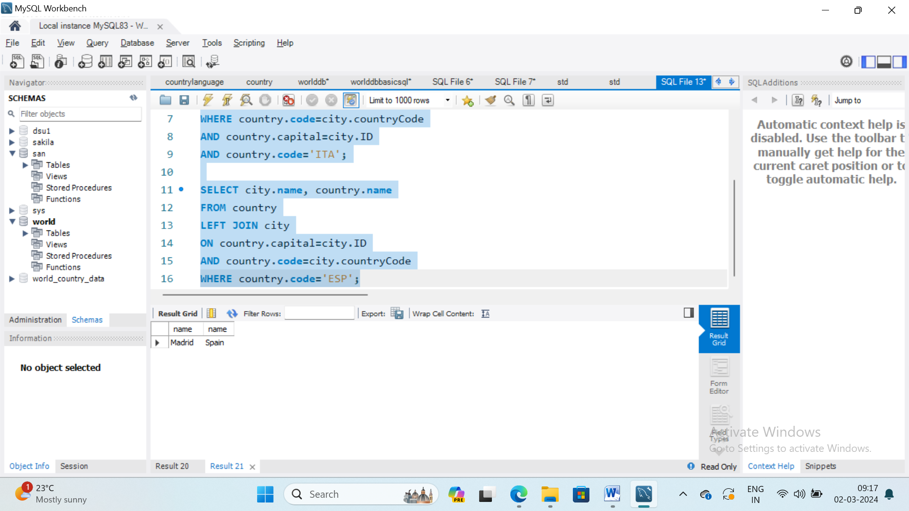

1. Using LEFT JOIN, ON, list all the languages spoken in the 'Southeast Asia' region (65)

SELECT LANGUAGE,region

FROM countrylanguage

LEFT JOIN country

ON countrylanguage.CountryCode=country.code

WHERE country.region='Southeast Asia';

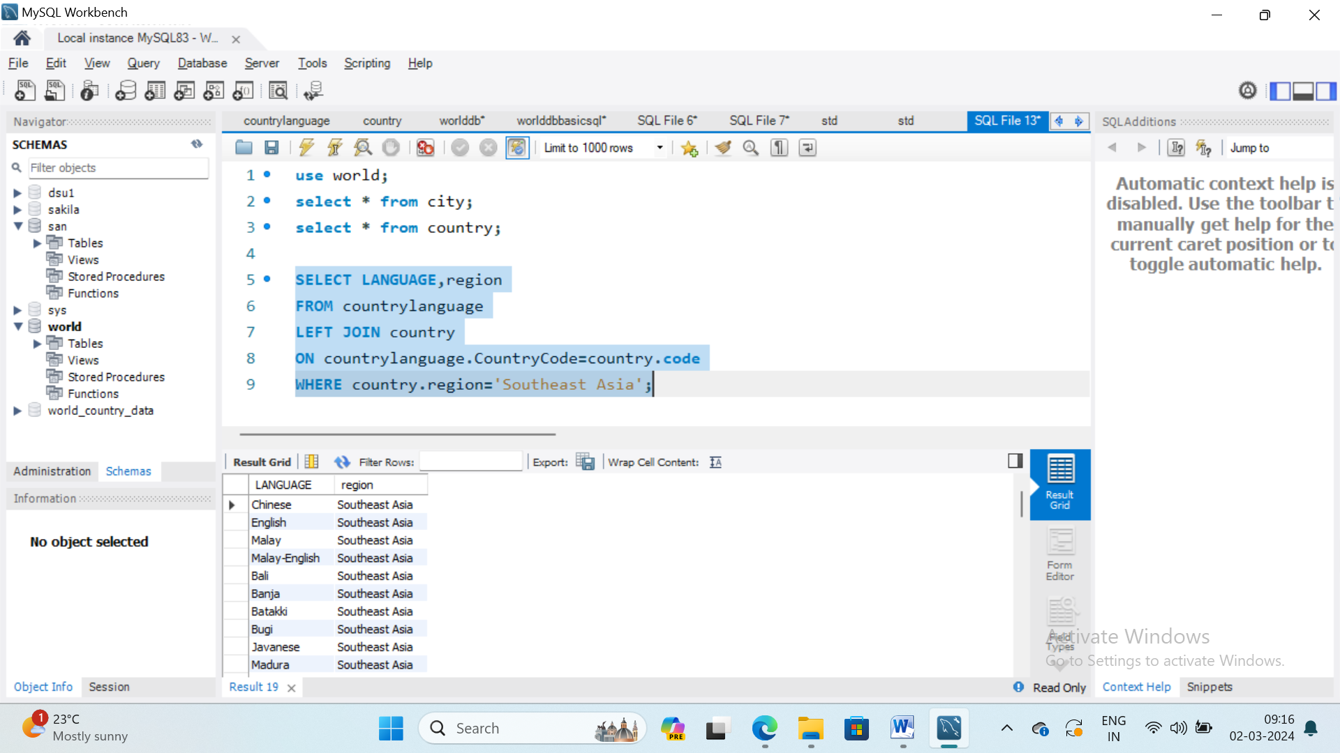

Extra code for practice:

SELECT *column_name(s)*  
FROM *table1*  
INNER JOIN *table2*ON *table1.column_name*=*table2.column_name*;

SELECT *column_name(s)*  
FROM *table1*  
RIGHT JOIN *table2*ON *table1.column_name*=*table2.column_name*;

SELECT *column_name(s)*  
FROM *table1*  
LEFT JOIN *table2*ON *table1.column_name*=*table2.column_name*;

SELECT *column_name(s)*  
FROM *table1*  
FULL OUTER JOIN *table2*ON *table1.column_name*=*table2.column_name*

WHERE *condition*;

VIVA QUESTIONS:

# EXPERIMENT: 4

# AIM: Execute the Aggregate functions count, sum, avg, min, max on a suitable database. Make use of built in functions according to the need of the database

PROGRAM:

1. Using count, get the number of cities in the USA (274)

SELECT COUNT(*) FROM city, country

WHERE country.code=city.countryCode

AND country.name='United States';

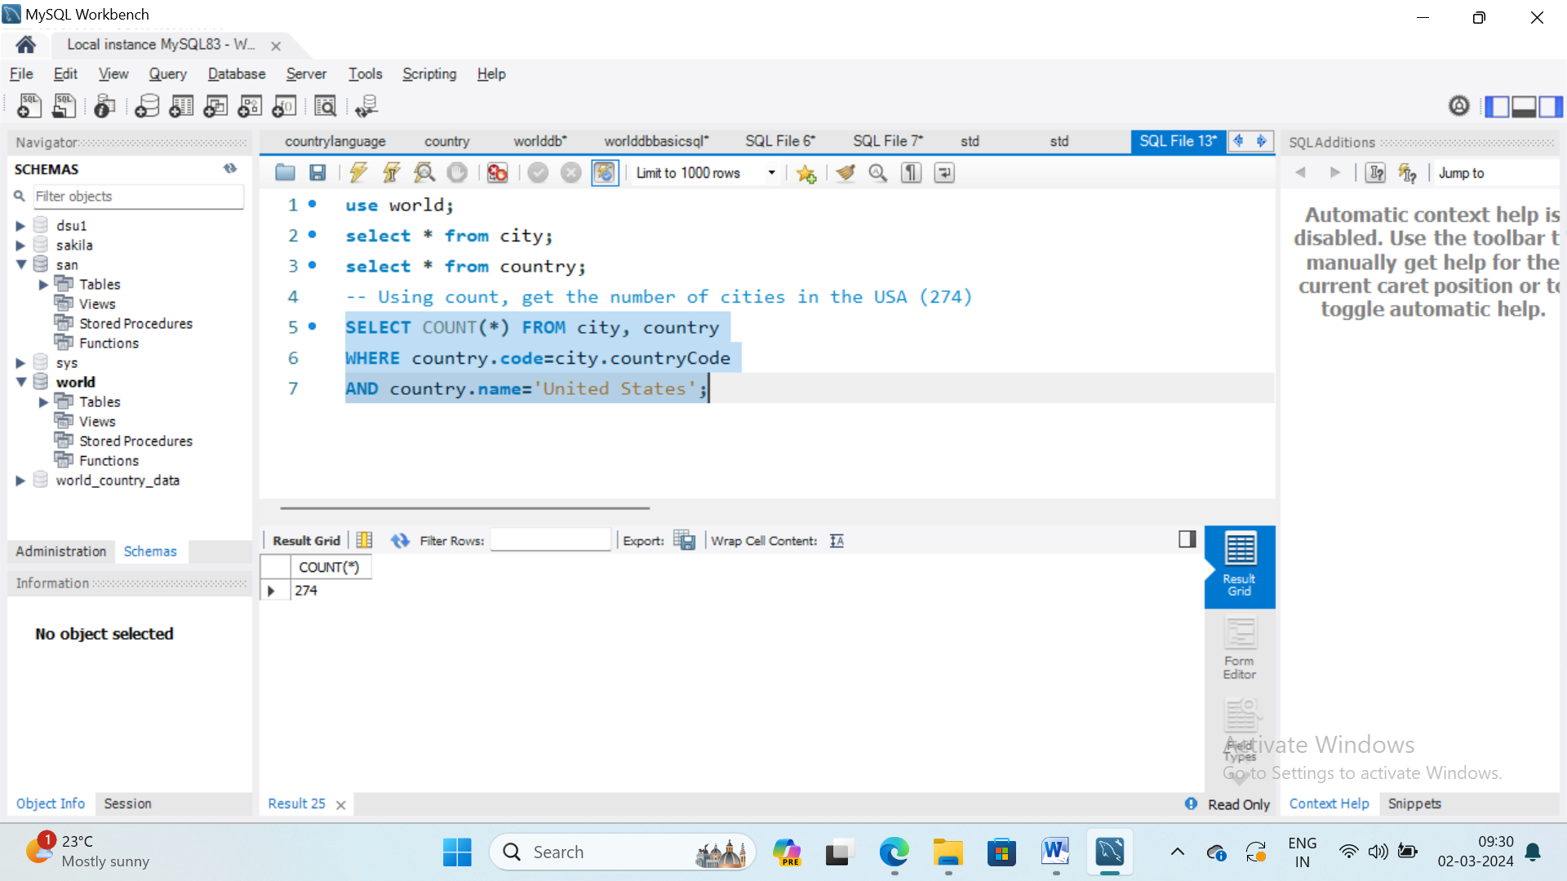

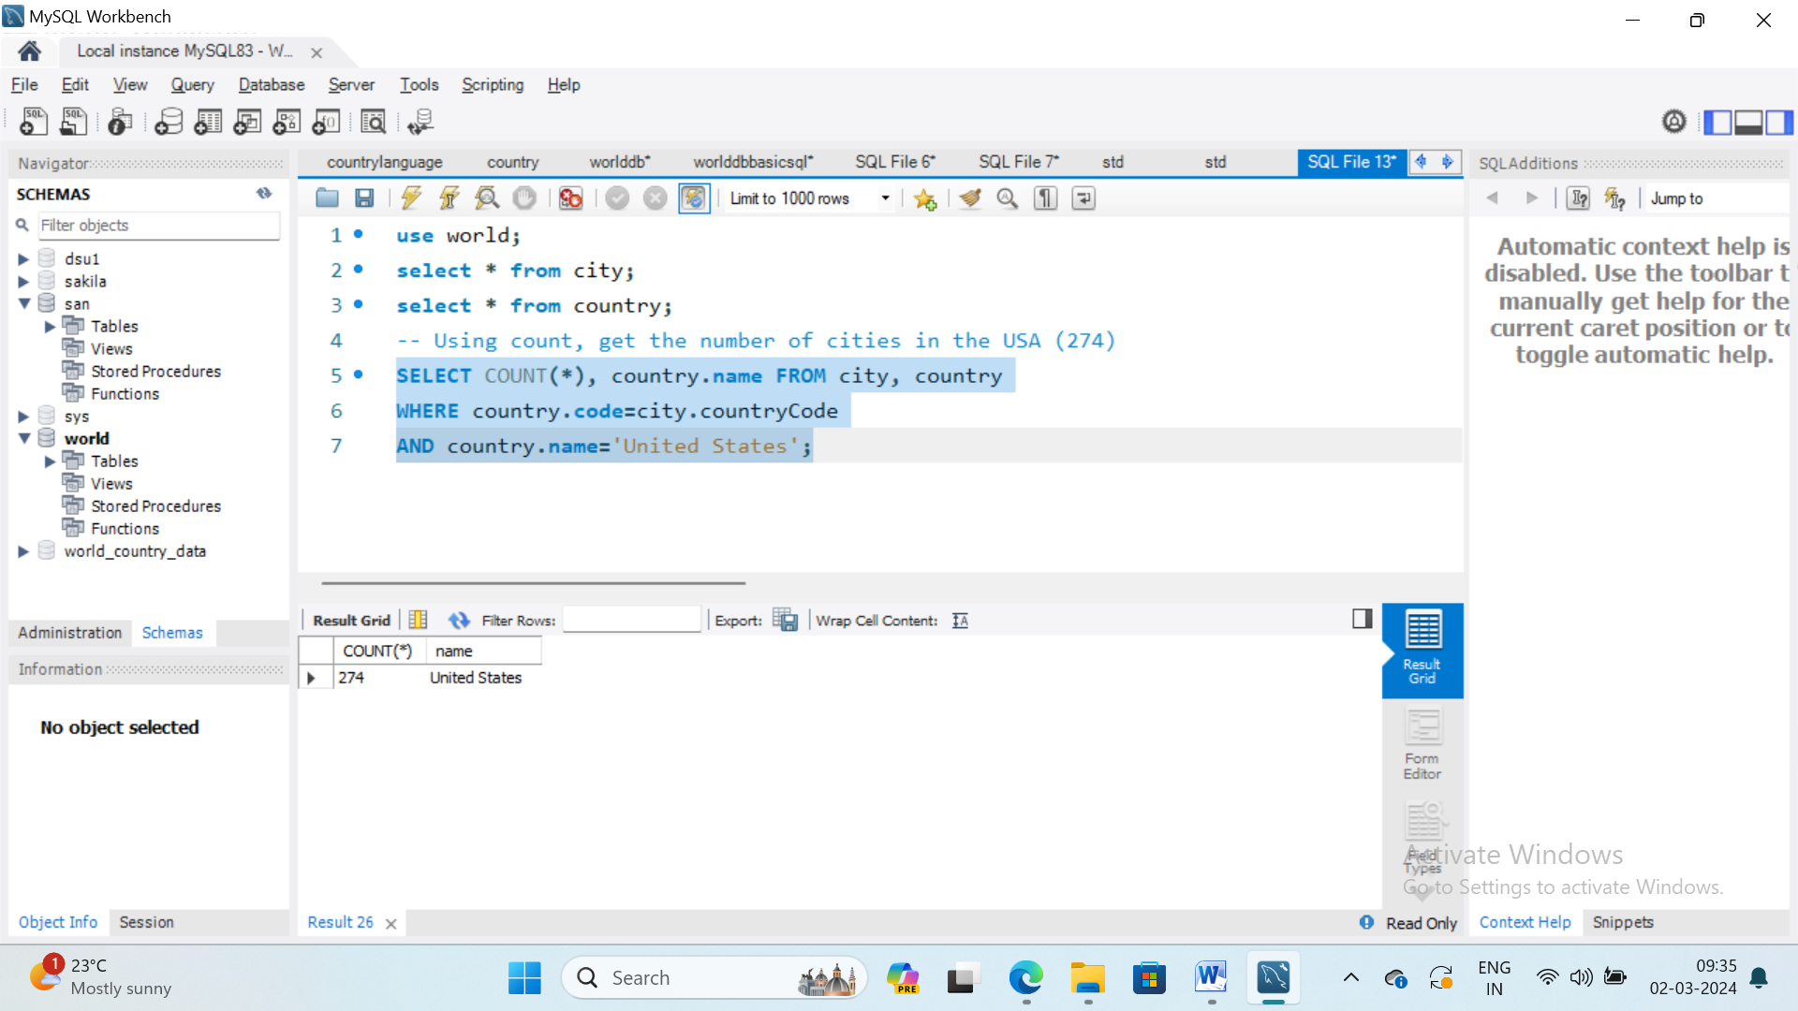

1. Get count of coutrycode where countrycode > 100

select count(countrycode),countrycode from city

group by countrycode

having count(countrycode)>100;

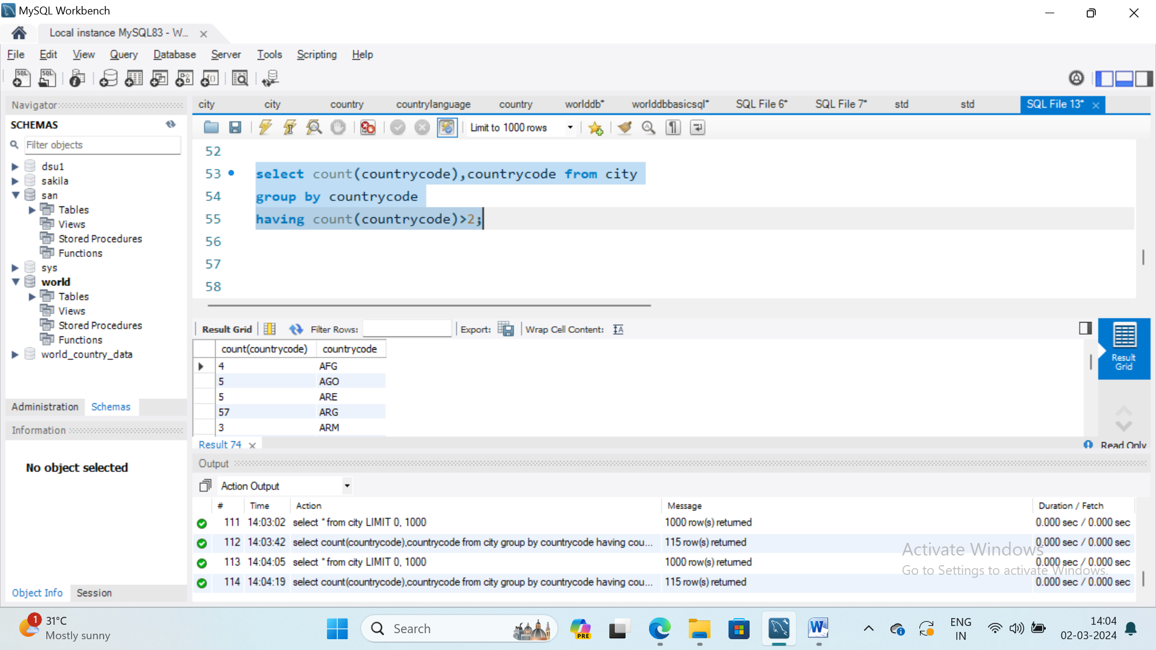

1. Find total districts in each country.

SELECT countrycode, country,COUNT(*) AS District

FROM city

GROUP BY countrycode;

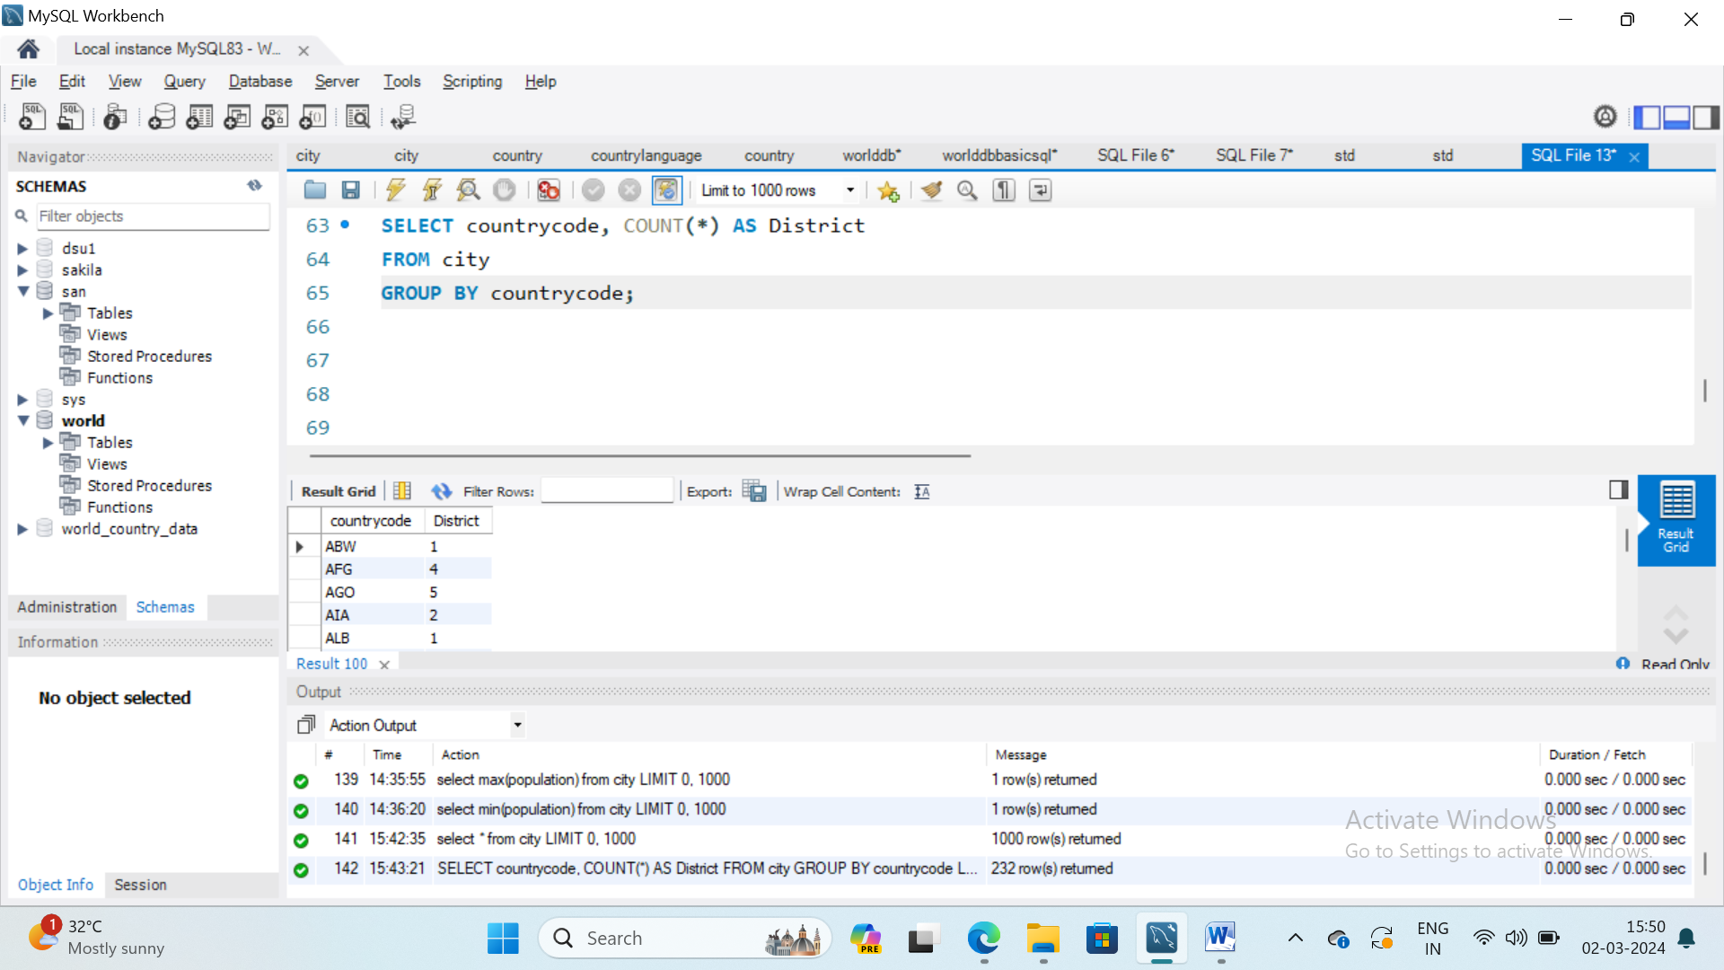

VIVA QUESTIONS:

# EXPERIMENT: 5

AIM: Retrieve the data from the database based on time and date functions like now(), date(), day(), time() etc., Use of group by and having clauses.

PROGRAM:

# SELECT NOW();

# SELECT CURDATE();

# SELECT CURTIME();

# 

Sakila database schema or ERD

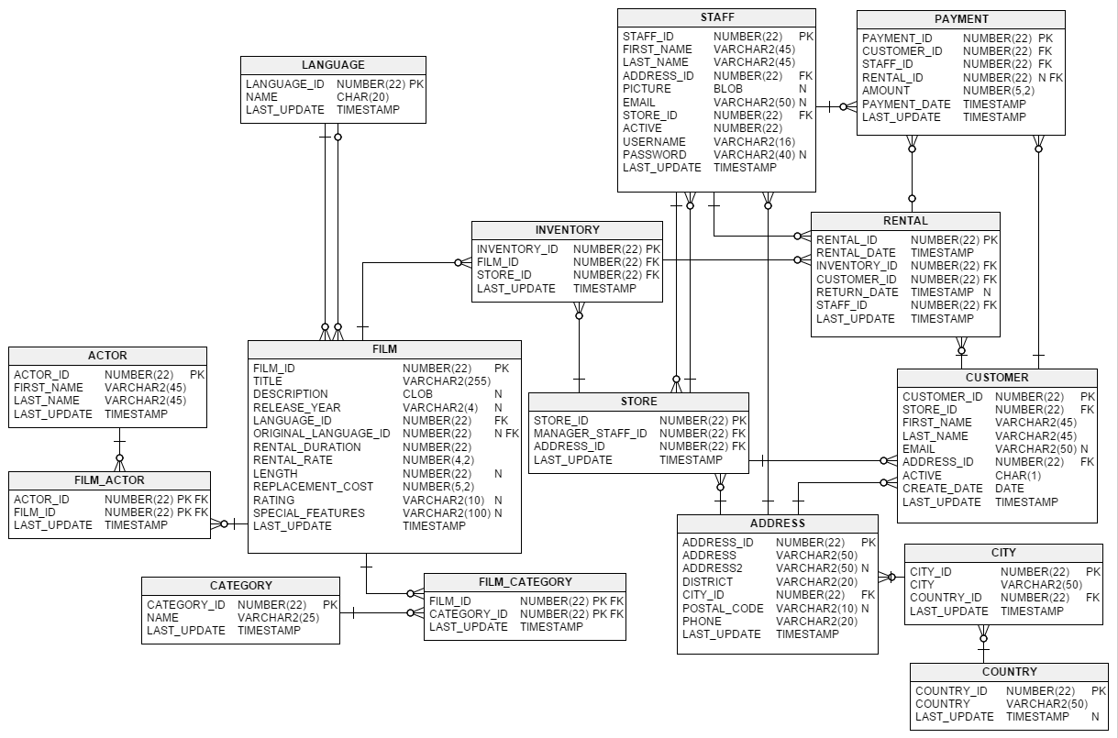

1. **Actor with most films (ignoring ties) from sakila database**

SELECT first_name, last_name, count(*) films

FROM actor AS a

JOIN film_actor AS fa USING (actor_id)

GROUP BY actor_id, first_name, last_name

ORDER BY films DESC

LIMIT 1;

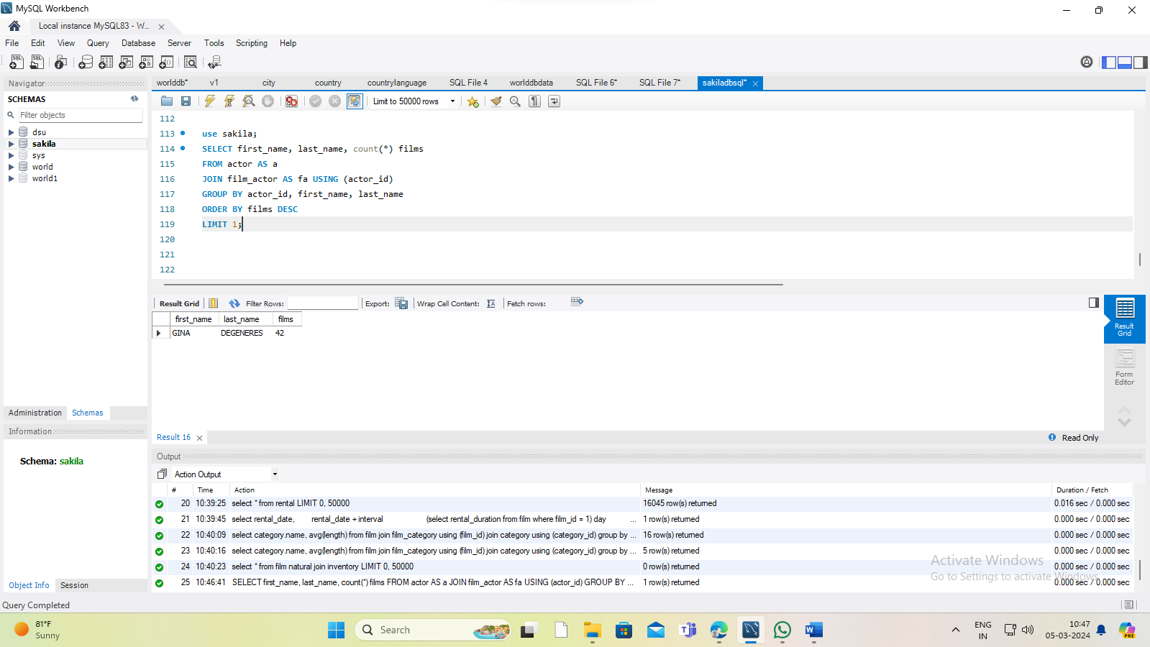

1. **Cumulative revenue of all stores**

SELECT payment_date, amount, sum(amount) OVER (ORDER BY payment_date) FROM (SELECT CAST(payment_date AS DATE) AS payment_date, SUM(amount) AS amount FROM payment

GROUP BY CAST(payment_date AS DATE)) ORDER BY payment_date;

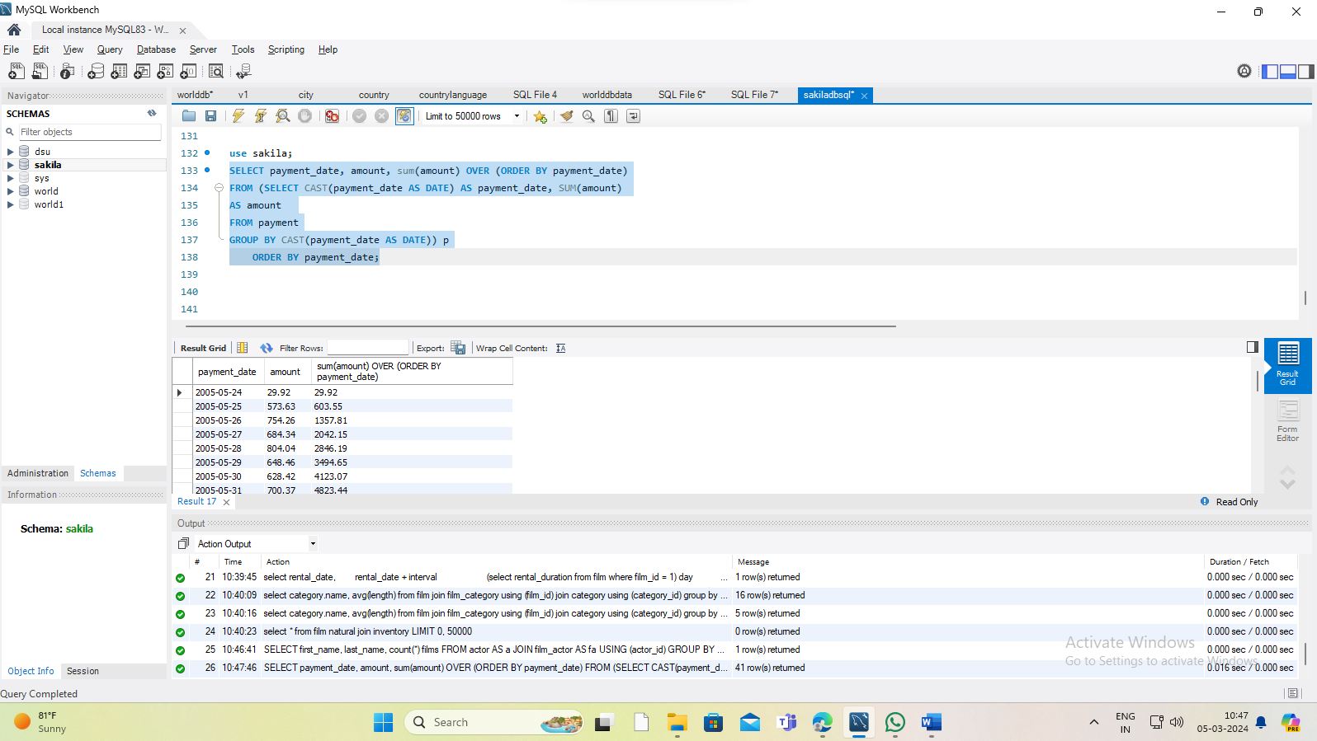

VIVA QUESTIONS:

# EXPERIMENT: 6

AIM: Write and execute database trigger. Consider row level and statement level

triggers.

PROGRAM:

CREATE TABLE test1(a1 INT);

CREATE TABLE test2(a2 INT);

delimiter |

CREATE TRIGGER testref1 BEFORE INSERT ON test1

FOR EACH ROW

BEGIN

INSERT INTO test2 SET a2 = NEW.a1;

END;

|

delimiter ;

INSERT INTO test1 values (10000);

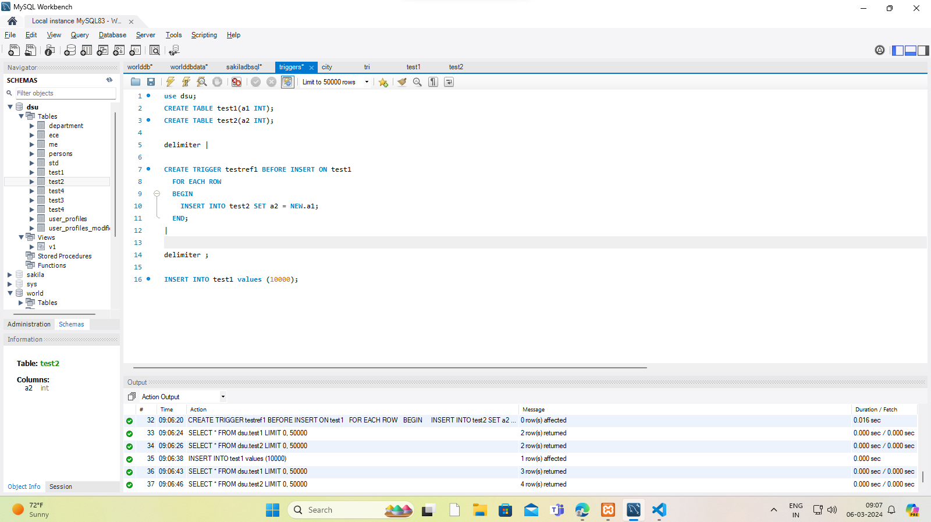

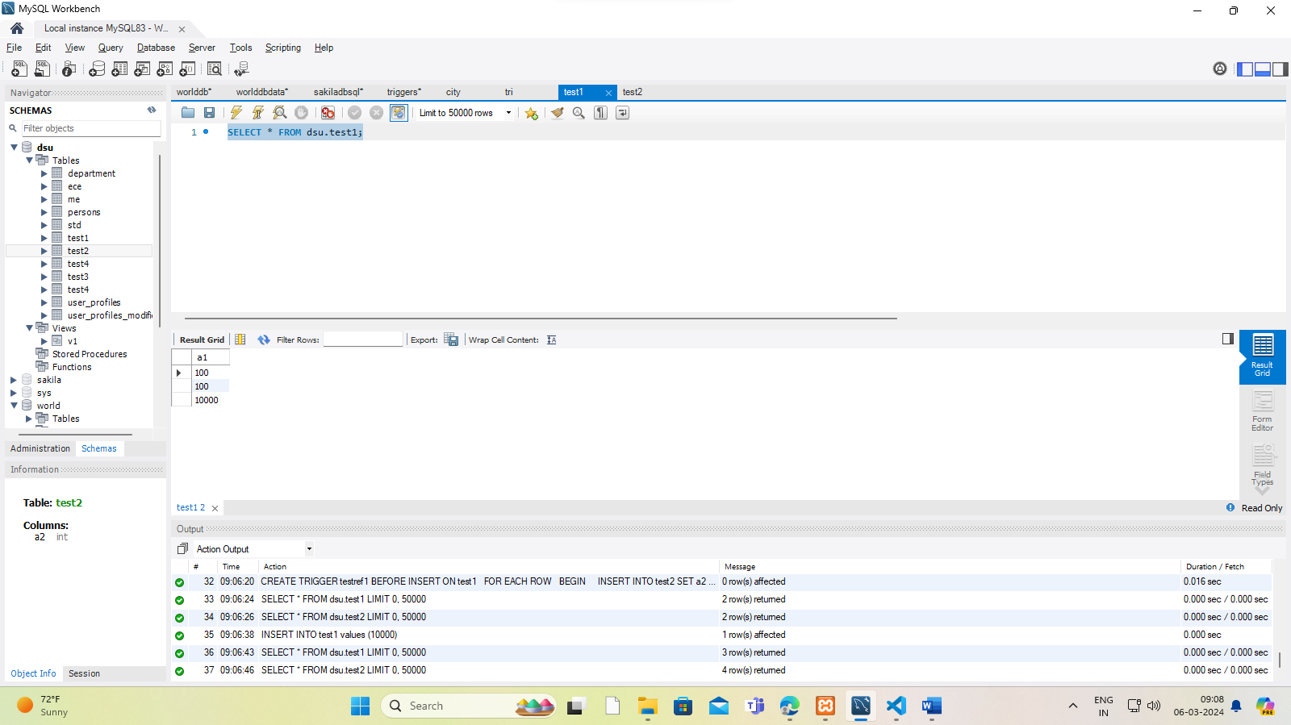

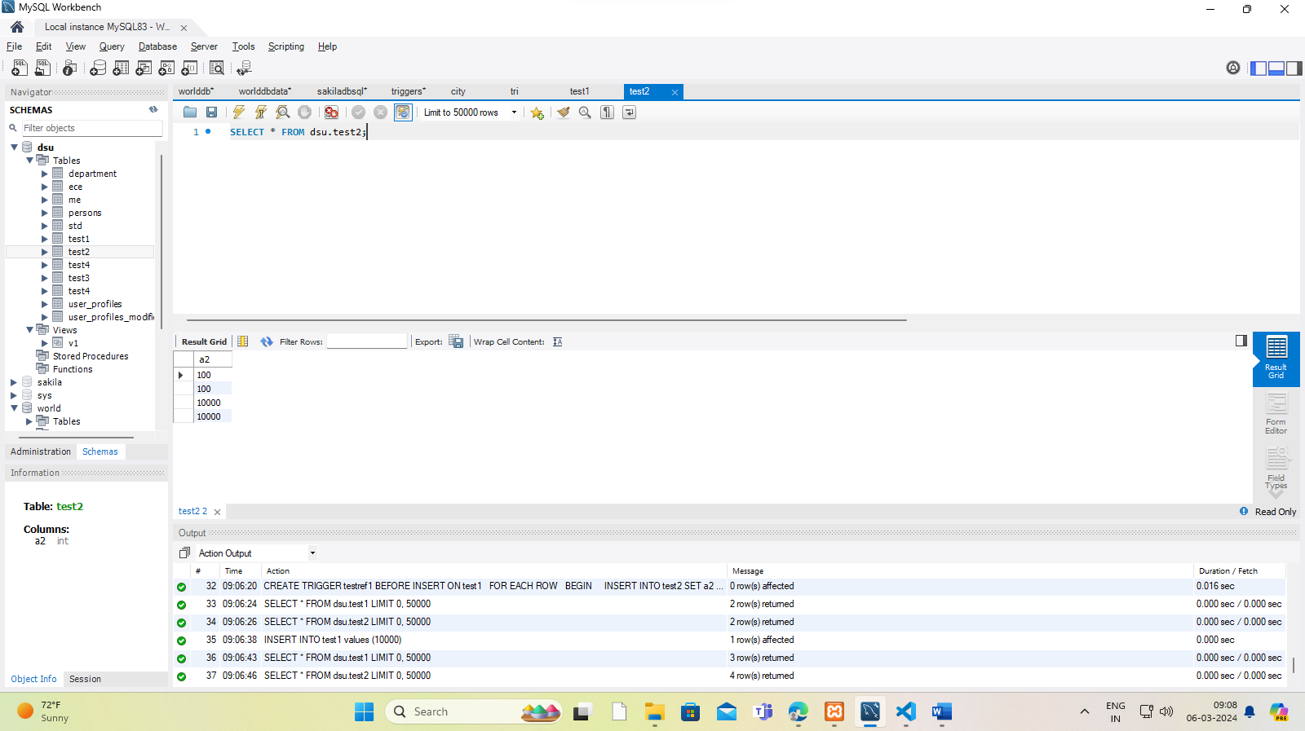

CREATE TABLE test1(a1 INT);

CREATE TABLE test2(a2 INT);

CREATE TABLE test3(a3 INT NOT NULL AUTO_INCREMENT PRIMARY KEY);

CREATE TABLE test4(

a4 INT NOT NULL AUTO_INCREMENT PRIMARY KEY,

b4 INT DEFAULT 0

);

delimiter |

CREATE TRIGGER testref BEFORE INSERT ON test1

FOR EACH ROW

BEGIN

INSERT INTO test2 SET a2 = NEW.a1;

DELETE FROM test3 WHERE a3 = NEW.a1;

UPDATE test4 SET b4 = b4 + 1 WHERE a4 = NEW.a1;

END;

|

delimiter ;

INSERT INTO test3 (a3) VALUES

(NULL), (NULL), (NULL), (NULL), (NULL),

(NULL), (NULL), (NULL), (NULL), (NULL);

INSERT INTO test4 (a4) VALUES

(0), (0), (0), (0), (0), (0), (0), (0), (0), (0);

# 

# 

# 

# 

# 

VIVA QUESTIONS:

# EXPERIMENT: 7

# AIM: Write and execute program to perform operations on MongoDb Database.

PROGRAM:

# a) Show databases

# 

# Use databasename

# insertone()

# insertmany()

# Findone()

# Findmany()

# mongodb download and install

# mongodb community server download and install

// const mongo1 = require('mongodb').MongoClient;

// const url1 = 'mongodb://localhost:27017';

// const client1 = new mongo1(url1);

// const dbname = 'e-comm';

// function f1() {

//     let conn = client1.connect(); // connect to mongo

//     let dbt = conn.db(dbname);    // connect to table of db

//     return dbt.collection('product')

// }

// module.exports=f1;

// const MongoClient = require('mongodb').MongoClient

// const url1 = 'mongodb://localhost:27017';

// const client = new MongoClient(url1);

// const dbname = 'e-comm';

// async function f1() {

//   let result = await client.connect(); // connect mongo db

//   let db = result.db(dbname)           // which data base

//   let collection = db.collection('product')  // which table

//   let response = await  collection.find({}).toArray()

//   console.log(response)

// }

// f1()

//===============

// download and install mongodb in local system

// install package in node ... using

// npm install mongodb

// npm install express //  additional framework

// npm install nodemon // additional package for application running

// import using require function with MongoClient

// const MongoClient = require('./mongodb').MongoClient

// To MongoClient object pass mongodb URL so that

// node will understand which port mongodb connected

// const client = new MongoClient('mongodb://localhost:27017')

// client.connect to connect to mongodb and node

// const result = *client*.connect()

// than const xx = result.db(dbname) to connect specific database

// const yy = xx.collection(tablename) to connect specific table

// than yy.find() to fetch all data from table

// async and await are used to handle (promise) delay //=======================++++++++++++++++++++++++++++++++

/////////////////// data fetch from table

const MC = require('mongodb').MongoClient

const url2 = 'mongodb://localhost:27017'

const res = new MC(url2)

const dbname2 = 'e-comm'

async function f2() {

let xx = await res.connect()

let yy = xx.db(dbname2)

let zz = yy.collection('product')

let r1 = await zz.find({}).toArray()

console.log(r1)

 }

f2()

///////////////  data insertion in to table

async function f3() {

let xx = await res.connect()

let yy = xx.db(dbname2)

let zz = yy.collection('product')

let r1 = await zz.insertOne({

"name": "S!!!!!",

"brand": "S1",

"price": 250,

"cat": "S11111"

})

if((await r1).acknowledged) {

console.log('data inserted')}

else {console.log(' not inserted') }

}

f3()

///////  data updation in to table ///////////////////////////////

async function f4() {

let xx = await res.connect()

let yy = xx.db(dbname2)

let zz = yy.collection('product')

let r1 = await zz.updateOne(

{name:'s-40'},

{$set:{name:'s111111-40'} }

)

console.warn(r1)

}

f4()

/////////////////  delete the data from mongodb

async function f5() {

let xx = await res.connect()

let yy = xx.db(dbname2)

let zz = yy.collection('product')

let r1 = await zz.deleteOne({name:'s-40'})

console.warn(r1)

}

f5()

//

//

1. Show dbs;
2. Create a database DSU than
3. Use DSU
4. Create collection(table)
5. DSU> db.cse.insertOne({ name:’Chirag111’, age:20, sal: 50000})
6. db.cse.find()
7. DSU> db.cse.insertOne({ name:’Chirag111’, age:20, sal: 50000})
8. DSU> db.cse.inserOne({ name:’Chirag222’, age:20, sal: 50000})
9. DSU>db.cse.find()
10. DSU>db.cse.findOne({name:’Chirag’})
11. DSU>db.cse.findOne({name:’Chirag111’})
12. Use databasename
13. Show collections
14. Db.createCollection (‘name of collection’)
15. Db.collectionname.find();
16. Db.collectionname.findOne({name:’xyz’})
17. Db.collectionname.inserOne({ name:’ddd’, age:20, sal: 50000})

VIVA QUESTIONS:

Experiment 8

Aim: Write and execute program to perform CRUD operations**.**

Program:

Create record, read record, update record and delete the record

1. Create operation

insertOne({

fName: 'RAM',

lName: 'AYODHYA',

email: 'ram@gmail.com',

hobbies: ['Photography', 'Travelling']

});

insertMany([{

fName: 'Adi',

lName: 'Yogi',

email: 'yogi@gmail.com',

hobbies: ['Drawing', 'Music']

}, {

fName: 'Modi',

lName: 'PM',

email: 'modi@gmail.com',

hobbies: ['Drawing', 'Classical Dance'] }]);

1. Read opearation

collection.find()

Output Data

VIVA Questions

**Mini Project:**

* For any problem selected, write the ER Diagram, apply ER-mapping rules, normalize the relations, and follow the application development process.
* Make sure that the application should have five or more tables, at least one trigger and one stored procedure, using suitable frontend tool.
* Indicative areas include: health care, education, industry, transport, supply chain etc.

# OPEN ENDED EXPERIMENTS

* 1. Implement the cursor function to process the result set in a row by row manner.
  2. Implement the pivot functions to perform cross tabulation.
  3. Implement Composite indexes that are created by using multiple columns to uniquely identify the data points.

**Extra sql code:**

**## SQL Homework**

**USE sakila;**

**## 1a. Display the first and last names of all actors from the table `actor`.**

SELECT first_name, last_name

FROM actor;

**## 1b. Display the first and last name of each actor in a single column in upper case letters. Name the column `Actor Name`.**

SELECT CONCAT (first_name,' ',last_name) as 'Actor Name'

FROM actor;

**## 2a. You need to find the ID number, first name, and last name of an actor, of whom you know only the first name, "Joe."**

**## What is one query you would use to obtain this information?**

SELECT actor_id, first_name, last_name

FROM actor

WHERE first_name = "Joe";

**## 2b. Find all actors whose last name contain the letters `GEN`:**

SELECT first_name, last_name

FROM actor

WHERE last_name LIKE "%GEN%";

**## 2c. Find all actors whose last names contain the letters `LI`.**

**## This time, order the rows by last name and first name, in that order:**

SELECT last_name, first_name

FROM actor

WHERE last_name LIKE "%LI%"

ORDER BY last_name;

**## 2d. Using `IN`, display the `country_id` and `country` columns of the following countries: Afghanistan, Bangladesh, and China:**

SELECT country_id, country

FROM country

WHERE country IN ('Afghanistan', 'Bangladesh', 'China');

**## 3a. Add a `middle_name` column to the table `actor`.**

**## Position it between `first_name` and `last_name`. Hint: you will need to specify the data # type.**

**## To get the data type of the colums**

DESCRIBE actor;

ALTER TABLE actor

ADD middle_name varchar(45) NOT NULL AFTER first_name;

SELECT * FROM actor;

**## 3b. You realize that some of these actors have tremendously long last names.**

**## Change the data type of the `middle_name` column to `blobs`.**

ALTER TABLE actor

MODIFY middle_name BLOB NOT NULL;

**## To get the data type of the colums**

DESCRIBE actor;

**## 3c. Now delete the `middle_name` column.**

ALTER TABLE actor

DROP middle_name;

DESCRIBE actor;

**## 4a. List the last names of actors, as well as how many actors have that last name.**

SELECT last_name, COUNT(*) AS 'Number of actors with last name'

FROM actor

GROUP BY last_name;

**## 4b. List last names of actors and the number of actors who have that last name, but only for names that are shared by at least two actors.**

SELECT last_name, COUNT(*) AS COUNT

FROM actor

GROUP BY last_name

HAVING COUNT >= 2;

**## 4c. Oh, no! The actor `HARPO WILLIAMS` was accidentally entered in the `actor` table as # `GROUCHO WILLIAMS`,**

**## the name of Harpo's second cousin's husband's yoga teacher. Write a query to fix the record,**

UPDATE actor SET first_name = REPLACE(first_name, 'GROUCHO','HARPO');

**## There should be no actor named 'GROUCHO WILLIAMS after the above query is run.**

**## To check run the following query.**

SELECT * FROM actor

WHERE first_name = "GROUCHO";

**## Check to see the change**

SELECT * FROM actor

WHERE first_name = "HARPO";

**## 4d. Perhaps we were too hasty in changing `GROUCHO` to `HARPO`.**

**## It turns out that `GROUCHO` was the correct name after all!**

**## In a single query, if the first name of the actor is currently `HARPO`, change it to #`GROUCHO`.**

**## Otherwise, change the first name to `MUCHO GROUCHO`, as that is exactly what the #actor will be with the grievous error.**

**## BE CAREFUL NOT TO CHANGE THE FIRST NAME OF EVERY ACTOR TO #`MUCHO GROUCHO`,**

**## HOWEVER! (Hint: update the record using a unique identifier.)**

UPDATE actor SET first_name = REPLACE(first_name,'HARPO', 'GROUCHO');

SELECT * FROM actor

WHERE first_name = "GROUCHO";

**##UPDATE actor SET first_name = REPLACE(first_name, 'MUCHO MUCHO MUCHO #GROUCHO', 'GROUCHO')**

##WHERE last_name = "WILLIAMS";

##UPDATE actor SET first_name = REPLACE(first_name, 'GROUCHO', 'HARPO')

##WHERE last_name = "WILLIAMS";

**## Check to see the change**

SELECT * FROM actor

WHERE last_name = "WILLIAMS";

**## 5a. You cannot locate the schema of the `address` table. Which query would you use to re-create it?**

SHOW CREATE TABLE address;

**## 6a. Use `JOIN` to display the first and last names, as well as the address, of each staff member. Use the tables `staff` and `address`**

SELECT s.first_name, s.last_name, a.address

FROM staff AS s

LEFT JOIN address AS a

ON (s.address_id = a.address_id);

**## 6b. Use `JOIN` to display the total amount rung up by each staff member in August of 2005. Use tables `staff` and `payment`.**

**## This gets the total amount for August 2005.**

SELECT CONCAT("$",FORMAT(SUM(amount),2)) AS Total FROM payment

WHERE payment_date LIKE '2005-08%';

**## This gets the total from each staff member. The amounts should add up to the total from the above query.**

SELECT s.first_name, s.last_name, p.staff_id, CONCAT("$",FORMAT(SUM(amount),2)) AS Total

FROM staff AS s

JOIN payment AS p

ON (s.staff_id = p.staff_id) AND p.payment_date LIKE '2005-08%'

GROUP BY p.staff_id;

**## 6c. List each film and the number of actors who are listed for that film. Use tables `film_actor` and `film`. Use inner join.**

SELECT f.title, COUNT(fa.actor_id) AS 'Number of Actors'

FROM film AS f

INNER JOIN film_actor AS fa

ON (f.film_id = fa.film_id)

GROUP BY f.film_id;

**## 6d. How many copies of the film `Hunchback Impossible` exist in the inventory system?**

SELECT f.title, (

SELECT COUNT(*) FROM inventory AS i

WHERE f.film_id = i.film_id

) AS 'Number of Copies'

FROM film AS f

WHERE f.title = "Hunchback Impossible";

**## 6e. Using the tables `payment` and `customer` and the `JOIN` command, list the total paid by each customer.**

**## List the customers alphabetically by last name:**

**## The total paid by each customer from the Payment table.**

SELECT customer_id, SUM(amount) AS 'Total Paid'

FROM payment

GROUP BY customer_id;

**## Displaying all the customers alphabetically by last name.**

SELECT last_name, first_name, customer_id

FROM customer

ORDER BY last_name ASC;

**## Combining the two with 'JOIN'**

SELECT c.first_name, c.last_name, CONCAT("$",FORMAT(SUM(p.amount),2)) AS 'Total Amount Paid'

FROM payment AS p

JOIN customer AS c

ON (p.customer_id = c.customer_id)

GROUP BY p.customer_id

ORDER BY c.last_name ASC;

**## 7a. The music of Queen and Kris Kristofferson have seen an unlikely resurgence.**

**## As an unintended consequence, films starting with the letters `K` and `Q` have also # # # # soared in popularity.**

**## Use subqueries to display the titles of movies starting with the letters `K` and `Q` whose # language is English.**

SELECT f.title

FROM film AS f

WHERE f.language_id IN (

SELECT l.language_id

FROM language AS l

WHERE f.title LIKE 'K%' OR f.title LIKE 'Q%' AND l.name = "English"

);

**## The movies that start with a "Q" or a "K" are all in English anyway.**

SELECT title, language_id

FROM film

WHERE title LIKE 'K%' OR title LIKE 'Q%' ;

**## 7b. Use subqueries to display all actors who appear in the film `Alone Trip`.**

SELECT first_name, last_name

FROM actor

WHERE actor_id IN (

SELECT actor_id

FROM film_actor

WHERE film_id IN (

SELECT film_id

FROM film

WHERE title = "Alone Trip")

);

**## 7c. You want to run an email marketing campaign in Canada,**

**## for which you will need the names and email addresses of all Canadian customers. Use joins to retrieve this information**

SELECT c.first_name, c.last_name, c.email, country.country

FROM address AS a

JOIN city

ON (city.city_id = a.city_id)

JOIN customer AS c

ON (c.address_id = a.address_id)

JOIN country

ON (country.country_id = city.country_id)

WHERE country.country = 'Canada';

**## 7d. Sales have been lagging among young families, and you wish to target all family movies for a promotion.**

**## Identify all movies categorized as family films.**

SELECT f.title, c.name AS 'Type of Film'

FROM category AS c

JOIN film_category AS fc

ON (fc.category_id = c.category_id)

JOIN film AS f

ON(f.film_id = fc.film_id)

WHERE c.name = "Family";

**## 7e. Display the most frequently rented movies in descending order.**

SELECT f.title, COUNT(f.title) AS 'Number_Rented'

FROM film AS f

JOIN inventory AS i

ON(i.film_id = f.film_id)

JOIN rental AS r

ON (i.inventory_id = r.inventory_id)

GROUP BY f.title

ORDER BY COUNT(f.title) DESC;

**## 7f. Write a query to display how much business, in dollars, each store brought in.**

SELECT s.store_id, CONCAT("$",FORMAT(SUM(p.amount),2)) AS 'Money Made'

FROM store AS s

JOIN inventory AS i

ON(i.store_id = s.store_id)

JOIN rental AS r

ON (r.inventory_id = i.inventory_id)

JOIN payment AS p

ON(p.rental_id = r.rental_id)

GROUP BY s.store_id;

**## 7g. Write a query to display for each store its store ID, city, and country.**

SELECT s.store_id, city.city, country

FROM store AS s

LEFT JOIN address AS a

ON(a.address_id = s.address_id)

INNER JOIN city

ON (city.city_id = a.city_id)

INNER JOIN country AS c

ON(c.country_id = city.country_id)

GROUP BY s.store_id;

**## 7h. List the top five genres in gross revenue in descending order.**

**## (**Hint**: you may need to use the following tables: category, film_category, inventory, payment, and rental.)**

SELECT cat.name AS 'Film Genre', CONCAT("$",FORMAT(SUM(p.amount),2)) AS 'Gross Revenue'

FROM category AS cat

JOIN film_category AS fc

ON(fc.category_id = cat.category_id)

JOIN inventory AS i

ON (i.film_id = fc.film_id)

JOIN rental AS r

ON(r.inventory_id = i.inventory_id)

JOIN payment AS p

ON(p.rental_id = r.rental_id)

GROUP BY cat.name

ORDER BY SUM(p.amount) DESC

LIMIT 5;

**## 8a. In your new role as an executive, you would like to have an easy way of viewing the Top five genres by gross revenue.**

**## Use the solution from the problem above to create a view.**

**## If you haven't solved 7h, you can substitute another query to create a view.**

CREATE VIEW top_five_genres AS

SELECT cat.name AS 'Film Genre', CONCAT("$",FORMAT(SUM(p.amount),2)) AS 'Gross Revenue'

FROM category AS cat

JOIN film_category AS fc

ON(fc.category_id = cat.category_id)

JOIN inventory AS i

ON (i.film_id = fc.film_id)

JOIN rental AS r

ON(r.inventory_id = i.inventory_id)

JOIN payment AS p

ON(p.rental_id = r.rental_id)

GROUP BY cat.name

ORDER BY SUM(p.amount) DESC

LIMIT 5;

**## 8b. How would you display the view that you created in 8a?**

SELECT * FROM top_five_genres;

**## 8c. You find that you no longer need the view `top_five_genres`. Write a query to delete it.**

DROP VIEW top_five_genres;

Extra code on sakila db……….

-- which actors have the first name 'scarlett'

select first_name, last_name

from actor

where first_name = 'scarlett';

-- which actors have the last name 'johansson'

select first_name, last_name

from actor

where last_name = 'johansson';

-- how many distinct actors last name are there

select distinct last_name, count(last_name)

from actor

group by last_name;

-- which last names are not repeated

select distinct last_name,count(last_name) as 'not repeated'

from actor

group by last_name

having count(last_name) ='1'

order by count(last_name);

-- which last names appear more than once

select last_name,count(last_name) as 'repeated'

from actor

group by last_name

having count(last_name) >'1'

order by count(last_name);

-- which actor has appeared in most films

select a.first_name,a.last_name, count(fa.actor_id) as 'film count'

from actor as a

inner join film_actor as fa on a.actor_id=fa.actor_id

group by a.actor_id

order by count(a.actor_id) desc;

-- is academy dinosaur available for rent in store 1

select *

from film as f

inner join inventory as i on f.film_id=i.inventory_id

inner join rental as r on r.inventory_id=i.inventory_id

where title='academy dinosaur' and store_id='1';

-- OR

select title,film_id,inventory_id,store_id

from inventory join film using (film_id) join store using(store_id)

where title= 'academy dinosaur' and store_id='1';

-- what is the average running time of all movies in the sakila database?

select round(avg(length))

from film;

-- what is the average running time of film by category

select name, round(avg(length))

from film as f

inner join film_category as fc on f.film_id=fc.film_id

inner join category as c on c.category_id=fc.category_id

group by c.name

order by round(avg(length)) desc;

-- display the first name and last name of all actors from the table actor

select first_name, last_name

from actor;

-- display the first name and last name of all actors in a single column in upper case letters. name the column actor name.

select upper (concat(first_name,' ',last_name)) as 'Actor name'

from actor;

-- you need to find the id number , first name, last name of an actor, of whom you know only the first name, 'joe'. what is one query would you use to obtain this information.

select actor_id, first_name, last_name

from actor

where first_name='joe';

-- find all actors whose last name contain the letter GEN

select first_name, last_name

from actor

where last_name like '%gen%';

-- find all actors whose last names contain the letter LI. this time, order the rows by last name and first name in that order

select last_name, first_name

from actor

where last_name like '%LI%'

order by last_name,first_name;

-- using IN, display the country id and country columns of the following countries; afghanistan,bangladesh,china.

select country,country_id

from country

where country in ('afghanistan','bangladesh','china');

-- list the last names of actors, as well as how many actors have that last name

select last_name, count(last_name) as 'actors with same last name'

from actor

group by last_name;

-- list last names of actors and the number of actors who have the last name but only for names that are shared by at least two actors.

select last_name, count(last_name)

from actor

group by last_name

having count(last_name) >'2' order by count(last_name) desc;